Name: ____________________________ Surname: ____________________________ N^{ber}: ____ Grade/Class: _____
Assessment: _____________________________  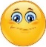 | Date: ___________________________________________________
 | Teacher’s signature:  ___________________________ | Parent’s signature:  ___________________________

- Read. Put a tick or a cross.

Amy is at the playground. There is a kite on the tree.
There is a ball in the sand.
There isn’t a swing. There is a slide.
There is a seesaw. There isn’t a bench.

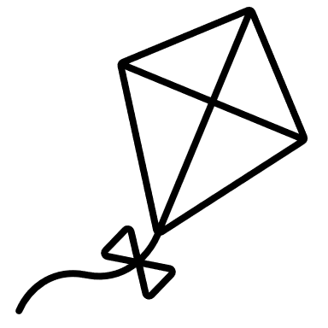 |  | 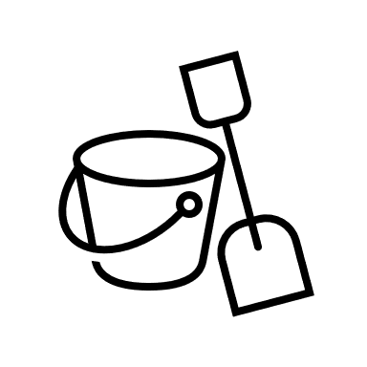 | 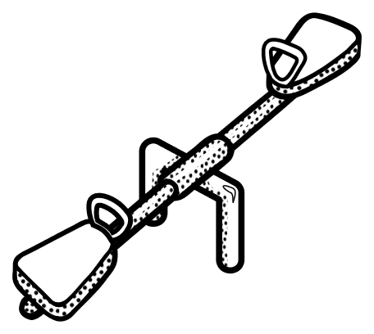 | 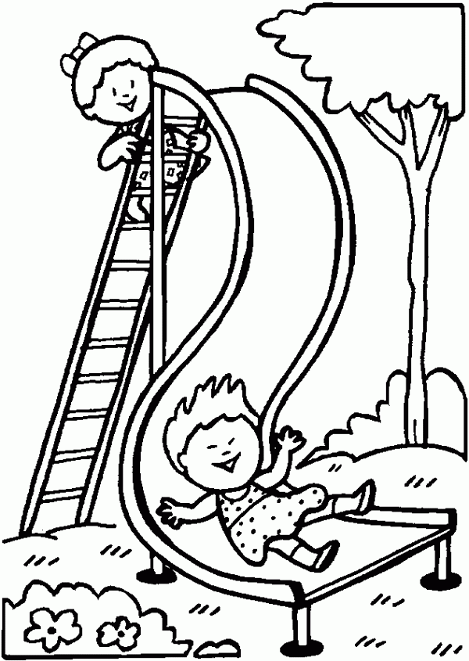 | 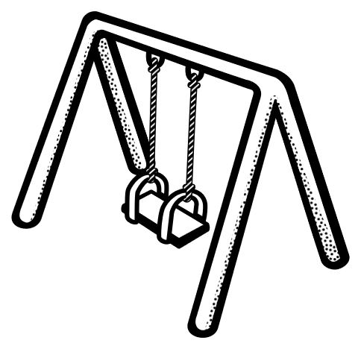 | 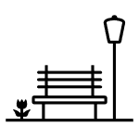

- Read and write the names.
_________ ________
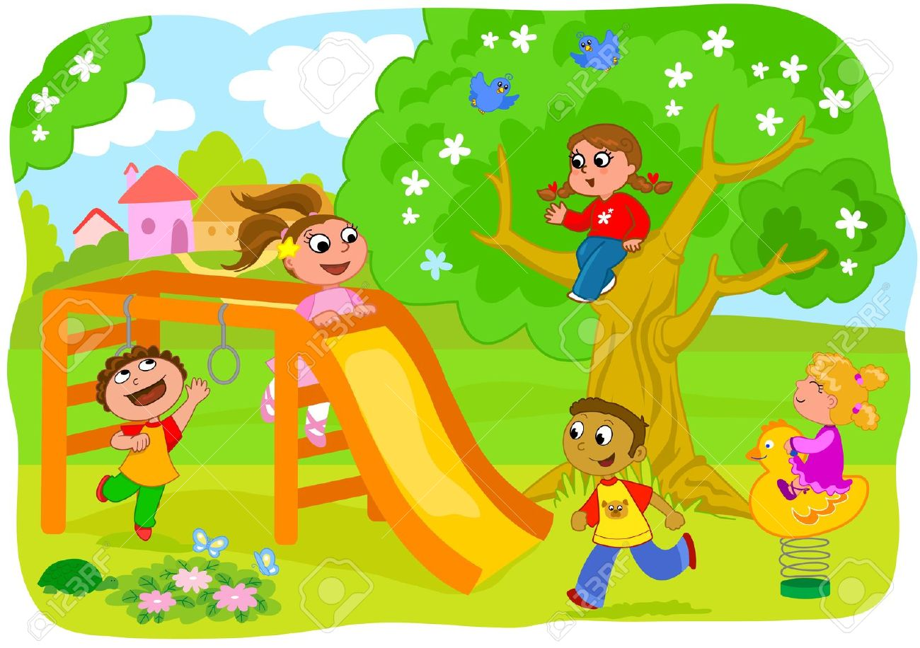
- Amy is on the tree.
- Molly is on the slide.
- Alex is under the slide.
- Simba is next to the slide.
- Susan is next to Simba.
_________ ________ ________

Answer key
1.

Yes | yes | yes | no | yes | no | No

2. Up - Molly, Amy
Down - Alex, Martin, Susan

