Name: ____________________________ Surname: ____________________________ N^{ber}: ____ Grade/Class: _____
Assessment: _____________________________ | Date: ___________________________________________________
 | Teacher’s signature:  ___________________________ | Parent’s signature:  ___________________________

- Look at the picture and say.

What do you see in the picture? (For example: The children are in the ……..)

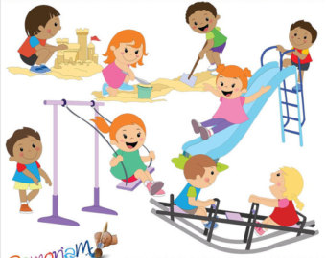

- Look at the picture again and say:
- How many children are there?
- How many children are playing in the sand?
- Where is the girl in red dress?
- Where is the girl in green T-shirt?

- Do you like to play in the sand?

Answer key
- The children are in the playground.

- a) There are nine children.
b) There are three children in the sand.
c) She is on the seesaw.
d) She is on the swing.

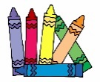
- Yes, I do/No, I don’t.

