Name: ____________________________ Surname: ____________________________ N^{ber}: ____ Grade/Class: _____
Assessment: _____________________________  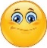 | Date: ___________________________________________________
 | Teacher’s signature:  ___________________________ | Parent’s signature:  ___________________________

- Look at the pictures and say.
Where is the ball?
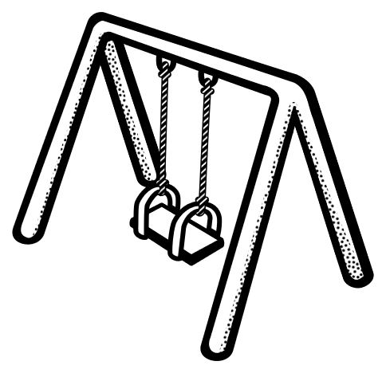
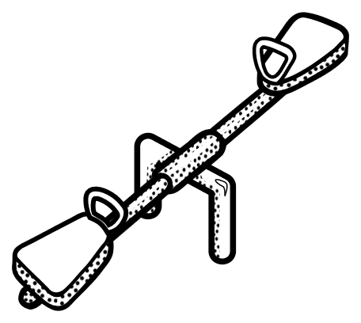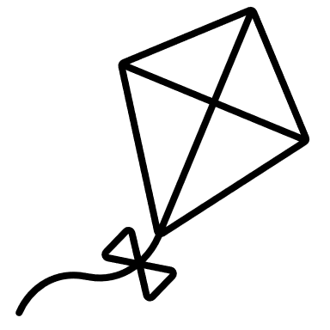

- Do you like to play with a ball?
Do you like to fly a kite?

Answer key

- The ball is under the swing.
The ball is above the seesaw.
The ball is next to the kite.

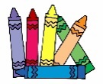
- Yes, I do/No, I don’t.

