Name: ____________________________ Surname: ____________________________ N^{ber}: ____ Grade/Class: _____
Assessment: _____________________________ | Date: ___________________________________________________
 | Teacher’s signature:  ___________________________ | Parent’s signature:  ___________________________

- Look at the picture and say:

Where are the children?
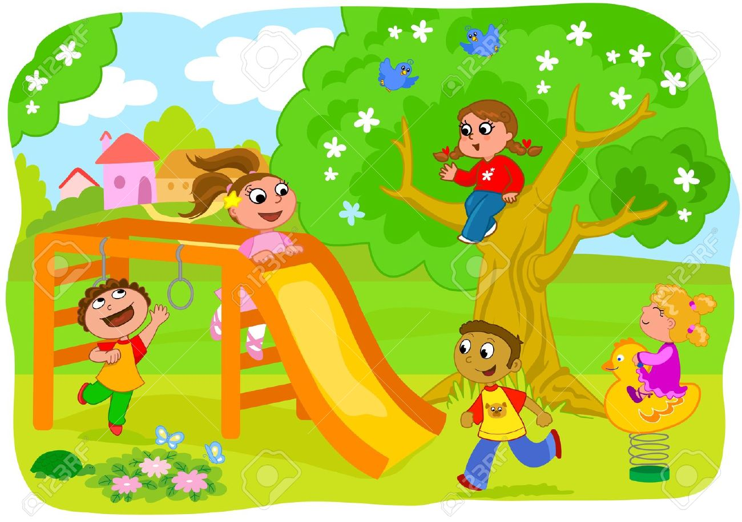

- Look at the picture again and say:
- Where is the boy in blue trousers?
- Where is the girl in red T-shirt?
- Where is the girl in pink dress?

- Do you like to play? How often do you go to the playground?

Answer key

- The children are in the playground.

- a) He is next to the slide.
b) She is on the tree.
c) She is on the slide

- Yes, I do/No, I don’t.

