Name: ____________________________ Surname: ____________________________ N^{ber}: ____ Grade/Class: _____
Assessment: _____________________________ | Date: ___________________________________________________
 | Teacher’s signature:  ___________________________ | Parent’s signature:  ___________________________

- Look at the picture and answer the questions.
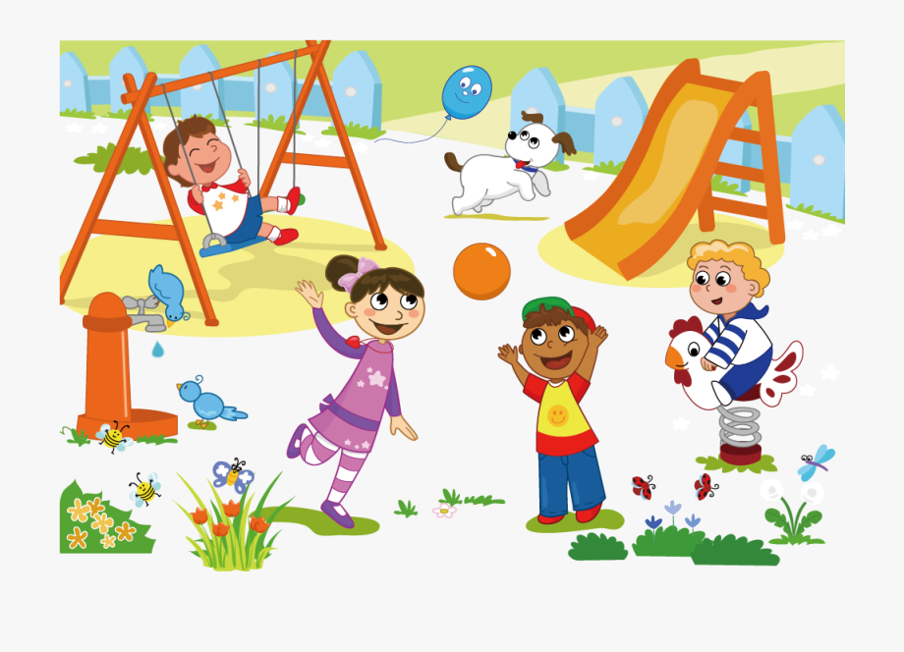

- Where is the boy in blue shorts?
- What are the girl in pink dress and the boy with a hat doing?
- Where is the slide?
- What is the dog doing?
- What animals are there?

2. Do you go to the playground with your friends?

3. What do you do in the playground?

Answer key

- a) He is on the swing.
b) They are playing with the ball.
c) The slide is next to the swing.
d) The dog is running.
e) There are birds, butterflies and a dog.

- Yes, I do/No, I don’t.

- I play ……. (the student’s choice of playing)

