Name: ____________________________ Surname: ____________________________ N^{ber}: ____ Grade/Class: _____
Assessment: _____________________________ | Date: ___________________________________________________
 | Teacher’s signature:  ___________________________ | Parent’s signature:  ___________________________

- Look at the picture and say:

What can you see in the picture?
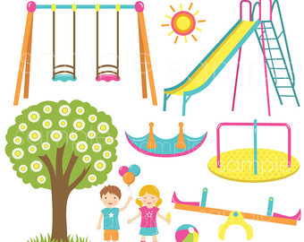

- Look at the picture again and say:
- Where is the ball?
- Where are the children?
- What does the boy have?
- Where is the swing?
- How is the weather like?

Answer key

- There are two children in the playground.

- a) The ball is under the seesaw.
b) The children are under the tree.
c) The boy has balloons.
d) The swing is next to the slide.
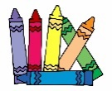
e) The weather is sunny.

