Name: ____________________________ Surname: ____________________________ N^{ber}: ____ Grade/Class: _____
Assessment: _____________________________  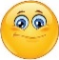 | Date: ___________________________________________________
 | Teacher’s signature:  ___________________________ | Parent’s signature:  ___________________________

- Unscramble the letters and colour.
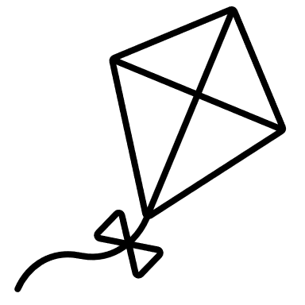
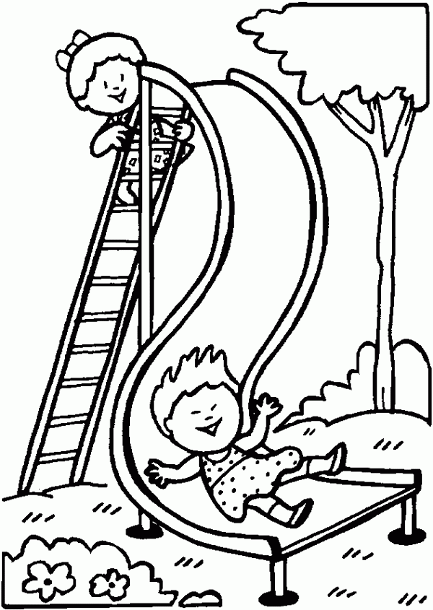
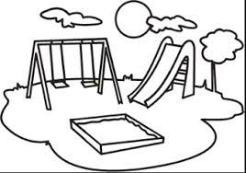

p_________________
y p l a r g u o d n
l i s e d
s_______________
i k t e
fly a k________

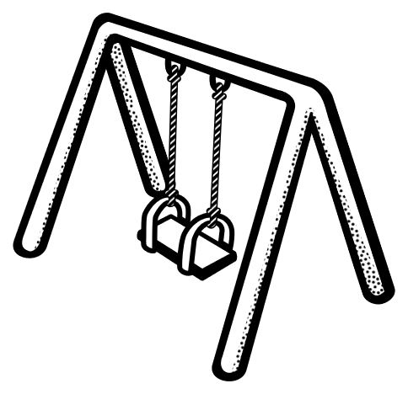
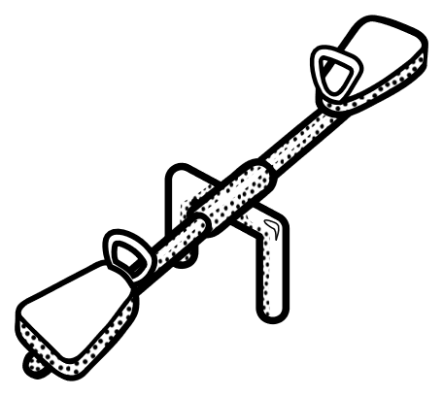

w s n i g
w a s s e e
s____________
s__________

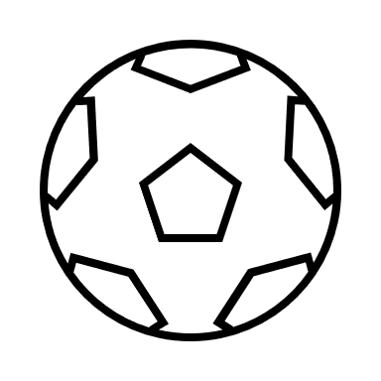
b________________
l a l b
play in the s____________
n a s d
b_______________
n c b e h
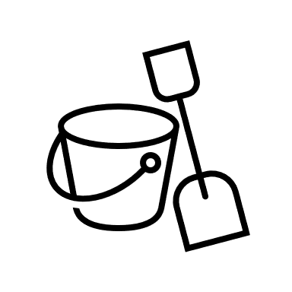
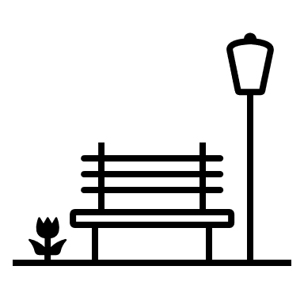

- Complete.
In the playground, I like ____________________________ and ____________________________ but I don’t like ____________________________.
Answer key
- Slide; playground; kite; seesaw; swing; ball; bench; sand.
- Depends on the student’s opinion.

