Name: ____________________________ Surname: ____________________________ N^{ber}: ____ Grade/Class: _____
Assessment: _____________________________ | Date: ___________________________________________________
 | Teacher’s signature:  ___________________________ | Parent’s signature:  ___________________________

- Find six words
p | l | a | y | g | r | o | u | n | d
s | e | e | s | a | w | u | r | r | r
w | a | o | a | h | t | p | p | o | h
i | m | j | n | e | d | h | g | p | a
n | b | l | d | g | j | d | j | e | q
g | a | n | h | v | v | a | f | g | y
y | l | h | t | h | f | r | a | a | f
s | l | i | d | e | k | f | t | w | e

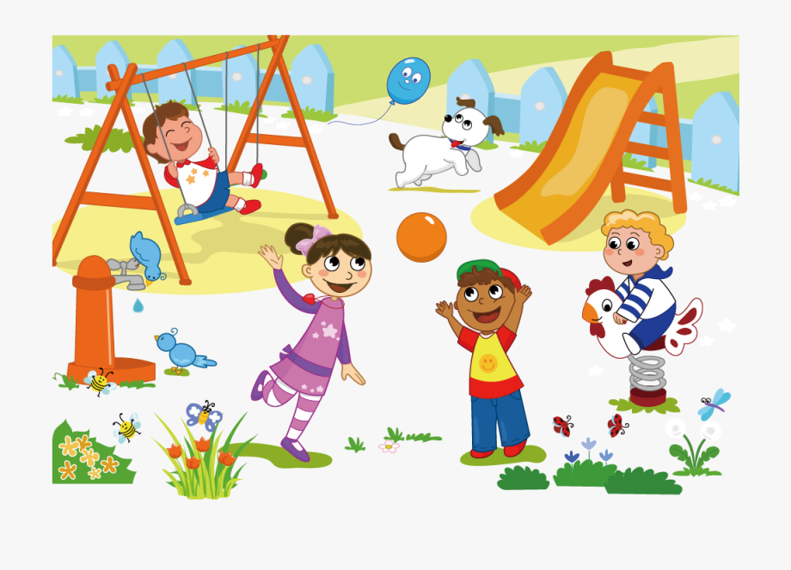
- Look at the picture and complete:
The boy is at the s _ _ _ _
The dog is next to the s _ _ _ _

Answer key

P | l | a | y | g | r | o | u | n | d
S | e | e | s | a | w
W |  |  | a
I |  |  | n
N | b |  | d
G | a
 | l
S | l | i | d | e

- swing; slide

