Name: ____________________________ Surname: ____________________________ N^{ber}: ____ Grade/Class: _____
Assessment: _____________________________ | Date: ___________________________________________________
 | Teacher’s signature:  ___________________________ | Parent’s signature:  ___________________________

- Find the words.
a s l I d e m s w i n g f t b a l l h k I t e s e e s a w d s a n d y p l a y g r o u n d

- Label the pictures.
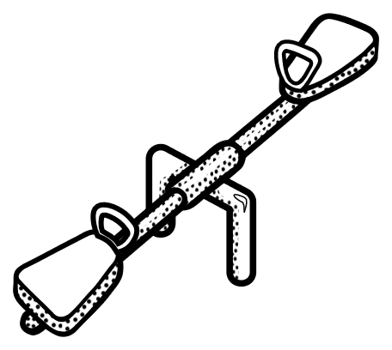

- ____________________ b) ____________________ c) ____________________
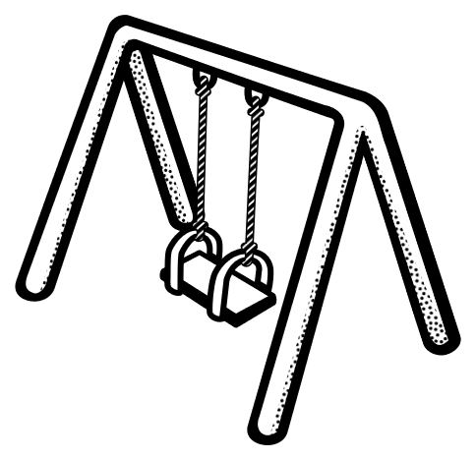
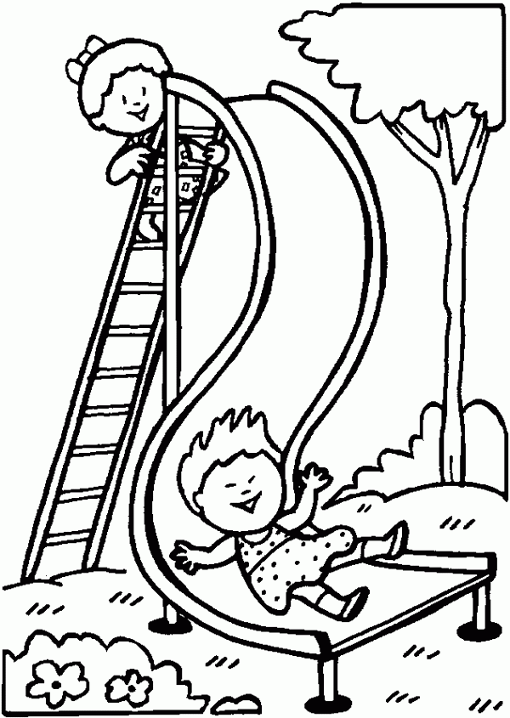

d)____________________ e) ____________________ f) ____________________

Answer key

- s l I d e s w i n g b a l l k I t e s e e s a w s a n d p l a y g r o u n d

- A) seesaw, b) ball, c) sand, d) swing, e) kite, f) slide

