Name: ____________________________ Surname: ____________________________ N^{ber}: ____ Grade/Class: _____
Assessment: _____________________________ | Date: ___________________________________________________
 | Teacher’s signature:  ___________________________ | Parent’s signature:  ___________________________

- Write and match.
- b __ __ l
- s __ __ s __ __ w
- s __ __d
- s __ __n __
- k __ t __
- p__ __ y g __ __ n d
- b __ __ c __

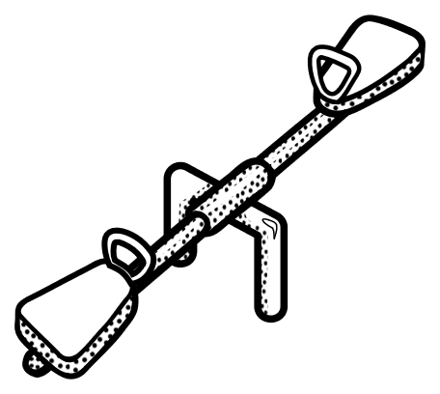
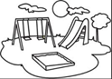
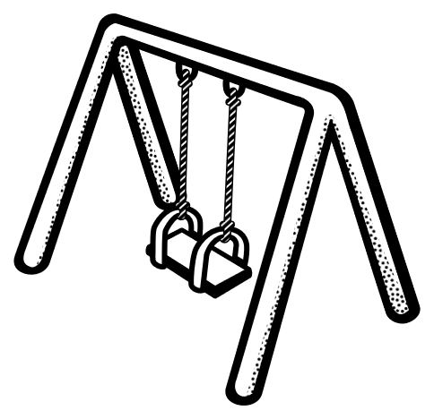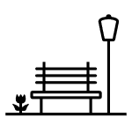

2) Look at the picture and circle the correct word.

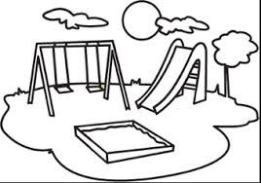
a. The sand / tree is in front of the swing.
b. The tree / slide is next to the swing.
c. The tree / sand is next to the slide.
d. There isn’t a slide / seesaw in the playground.

Answer key

- ball, seesaw, sand, swing, playground, kite, bench

- a) sand, b) slide, c) tree, d) seesaw

