Name: ____________________________ Surname: ____________________________ N^{ber}: ____ Grade/Class: _____
Assessment: _____________________________  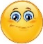 | Date: ___________________________________________________
 | Teacher’s signature:  ___________________________ | Parent’s signature:  ___________________________

- Read and complete.
Sally is in the pl_ _ g _ _ _ _ _. She is on the s_ _ _ _. Molly is on the _ _ _ _ _ too. There is also a sw_ _ _, a s_ _ s _ _ w and s _ _ d in the playground. They like to play with a b _ _ l, but they don’t like to fly a k _ t _.
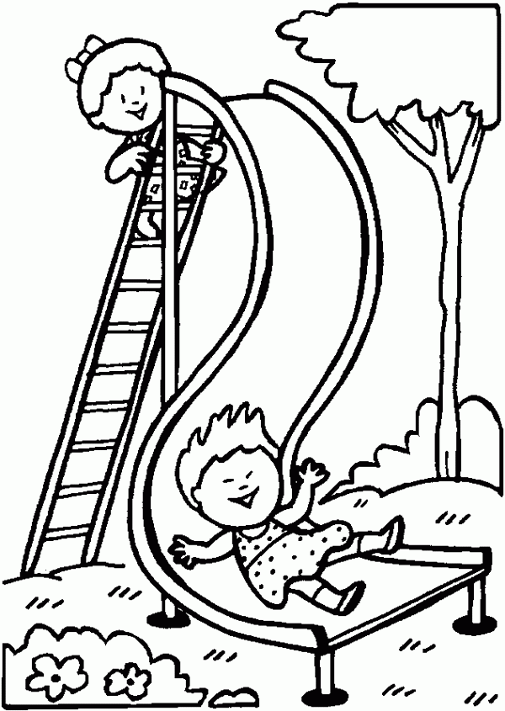

- Match, unscramble and write.
l l b a
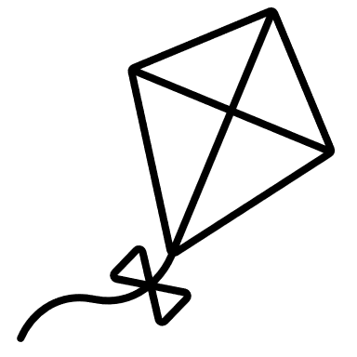
- _______________________
n s a d
- ______________________
- _______________________
- ______________________
- _______________________
w n s I g 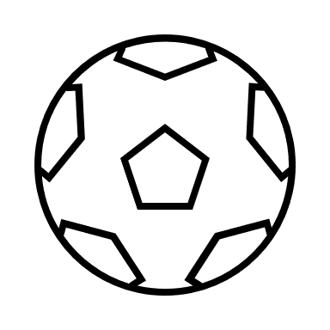
I k t e 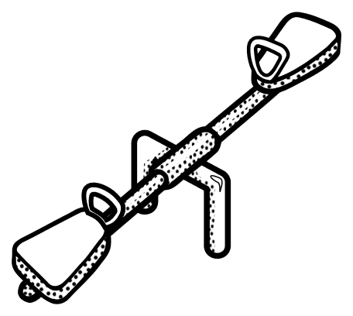
s w e e s a
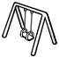
Answer key

- Playground, slide, slide. Swing, seesaw, sand, ball. Kite

- Kite, ball, seesaw, sand, swing

