Name: ____________________________ Surname: ____________________________ N^{ber}: ____ Grade/Class: _____
Assessment: _____________________________ | Date: ___________________________________________________
 | Teacher’s signature:  ___________________________ | Parent’s signature:  ___________________________

- Arrange the words in the correct order.

- is / The / boy / in / playground / the
_______________________________
- ball / The / is / slide / under / the
____________________________________.
____________________________________.
____________________________________.
____________________________________.

_______________________________
- kite / is / The / on / the / tree
________________________________
- is / The / swing / next to / slide
_________________________________
2) Look, match and write.
The children
The dog…
The slide…
The boy…
…is next to the dog.
are in the playground.
is next to the balloon.
…is on the swing.

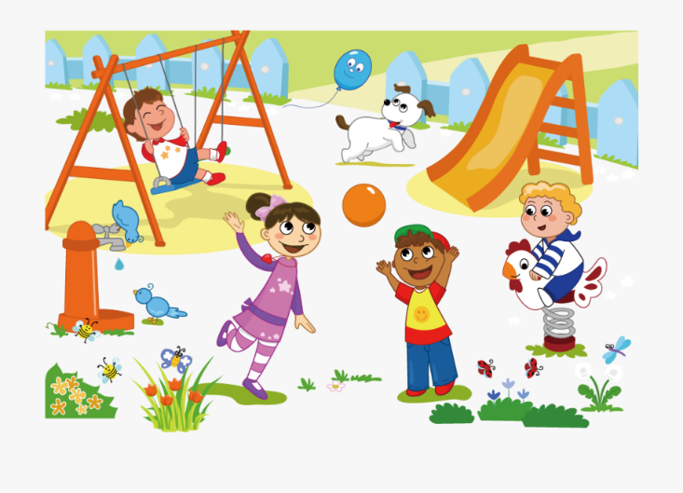

a) ____________________________________ b) ____________________________________

c) _____________________________________ d) _____________________________________

Answer key
- A) The boy is in the playground.
B) The ball is under the slide.
C) The kite is on the tree.
D) The swing is next to the slide (or The slide is next to the swing)
- The children are in the playground. The dog is next to the balloon. The slide is next to the dog. The boy is on the swing.

