Name: ____________________________ Surname: ____________________________ N^{ber}: ____ Grade/Class: _____
Assessment: _____________________________ | Date: ___________________________________________________
 | Teacher’s signature:  ___________________________ | Parent’s signature:  ___________________________

- Look and write.
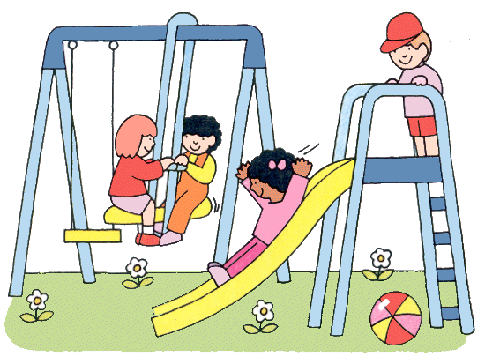
The b________ is under the s_________
The b___________ is on the s _________
The s___________ is next to the s______
- Write the following sentences in the negative form.
for example: The girl is under the tree.
The girl isn’t under the tree.

a) The is in the playground. ____________________________________

b) The is under the slide. ____________________________________
c) The slide is next to the _____________________________________
d) The is in the playground. _____________________________________

Answer key
- A) ball, slide b) boy, slide c) slide, swing or swing, slide
- The kite isn’t in the playground. The ball isn’t under the slide. The slide isn’t next to the tree. The girl isn’t in the playground.

