Name: ____________________________ Surname: ____________________________ N^{ber}: ____ Grade/Class: _____
Assessment: _____________________________ | Date: ___________________________________________________
 | Teacher’s signature:  ___________________________ | Parent’s signature:  ___________________________

- Colour and write.
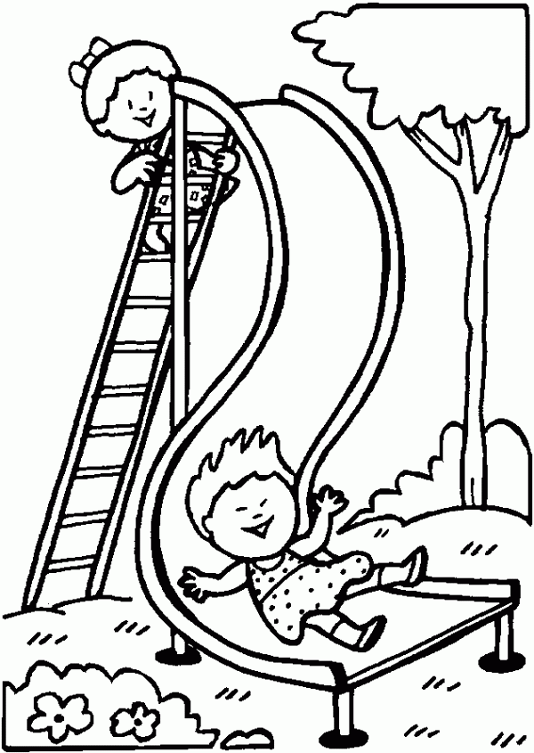
a) Where are the girls? The girls are in the p______________

b) Where are the girls? The girls are on the s______________
b) Where is the slide? The slide is next to the _____________

2. Arrange the words in the correct order.

- boys / the / Are / the / in / playground? ________________________________
- Are / friends / the / the / sand / in? __________________________________
- Is / Ann / the / on / slide? ___________________________________
- on / the / Is / tree / the / kite? ___________________________________

Answer key
- a) playground b) slide c) tree.
- Are the boys in the playground? Are the friends in the sand? Is Ann on the slide? Is the kite on the tree?

