TOPIC: Nature | SUBTOPICS: Naming Nature | LEVEL: A1
Name: ____________________________ Surname: ____________________________ N^{ber}: ____ Grade/Class: _____

TOPIC: Playground | SUBTOPICS: Fill in the blanks about Playground | LEVEL: A1
Name: ____________________________ Surname: ____________________________ N^{ber}: ____ Grade/Class: _____

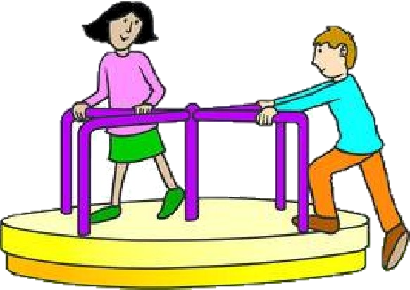
FILL IN THE BLANKS
1. What are they doing?
They are playing at the __ e r r __ g __ r __ __ n d.

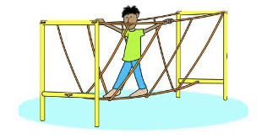
2. What is John doing?
John is passing at the r__ p __ b __ i d __ __.

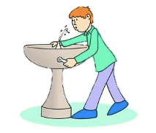

3. What is Michael doing?
Michael gets water from the d r __ i __ k __ n g f __ __n t a i __.

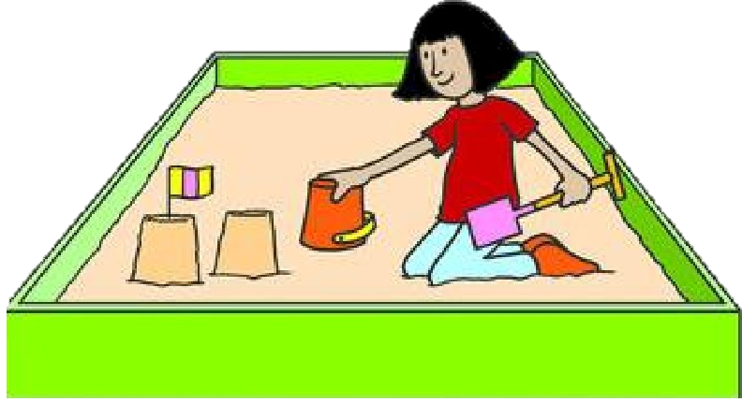

4. What is Karla doing?
Karla is assembling the buckets in the s __ n __ __ O X.

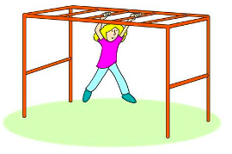
5. What is Christian doing?
Christian is playing at the m __ n k __ y b __ r.
ANSWER KEY
FILL IN THE BLANKS
1. What are they doing?
They are playing at the merry go round.

2. What is John doing?
John is passing at the rope bridge.

3. What is Michael doing?
Michael gets water from the drinking fountain.

4. What is Karla doing?
Karla is assembling the buckets in the sandbox.

5. What is Christian doing?
Christian is playing at the monkey bar.

