TOPIC: Nature | SUBTOPICS: Naming Nature | LEVEL: A1
Name: ____________________________ Surname: ____________________________ N^{ber}: ____ Grade/Class: _____

TOPIC: Playground | SUBTOPICS: Match the Playground | LEVEL: A1
Name: ____________________________ Surname: ____________________________ N^{ber}: ____ Grade/Class: _____

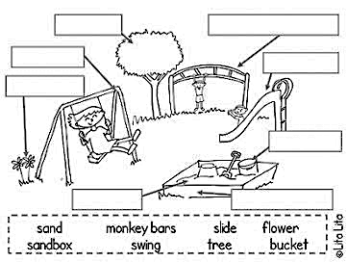
MATCH THE PLAYGROUND

TOPIC: Playground | SUBTOPICS: Match the Playground | LEVEL: A1
Name: ____________________________ Surname: ____________________________ N^{ber}: ____ Grade/Class: _____

sand monkey bars slide flower
sandbox tree bucket swing

MATCH THE PLAYGROUND
monkey bar
tree

slide
swing

flower
TOPIC: Playground | SUBTOPICS: Match the Playground | LEVEL: A1
Name: ____________________________ Surname: ____________________________ N^{ber}: ____ Grade/Class: _____

sand monkey bar slide flower
sandbox tree bucket swing

bucket

sandbox
sand

