TOPIC: Nature | SUBTOPICS: Naming Nature | LEVEL: A1
Name: ____________________________ Surname: ____________________________ N^{ber}: ____ Grade/Class: _____

TOPIC: Playground | SUBTOPICS: Color the Playground | LEVEL: A1
Name: ____________________________ Surname: ____________________________ N^{ber}: ____ Grade/Class: _____
COLOR THE PLAYGROUND
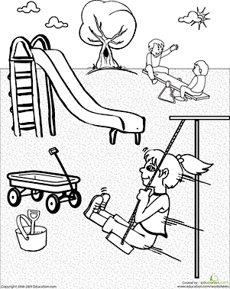

ANSWERS MAY VARY
COLOR THE PLAYGROUND

