TOPIC: Nature | SUBTOPICS: Naming Nature | LEVEL: A1
Name: ____________________________ Surname: ____________________________ N^{ber}: ____ Grade/Class: _____

TOPIC: Playground | SUBTOPICS: Match the Picture | LEVEL: A1
Name: ____________________________ Surname: ____________________________ N^{ber}: ____ Grade/Class: _____

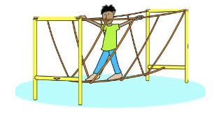
MATCH THE PICTURE
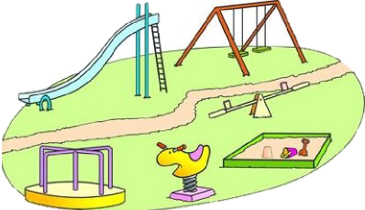
1. slide
2.merry go round
3. seesaw
4. sandbox
5. path
6. monkey bar
7. playground
8. climbing frame
9. rope bridge
10. drinking fountain

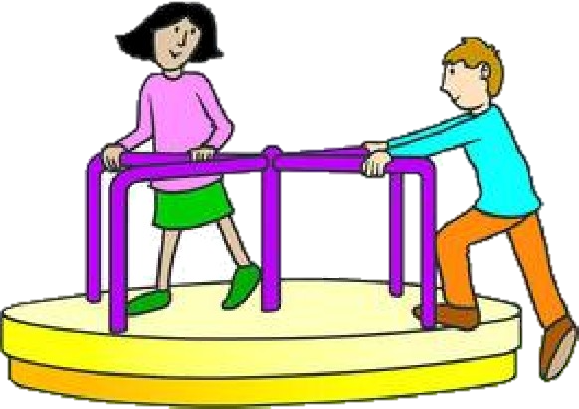
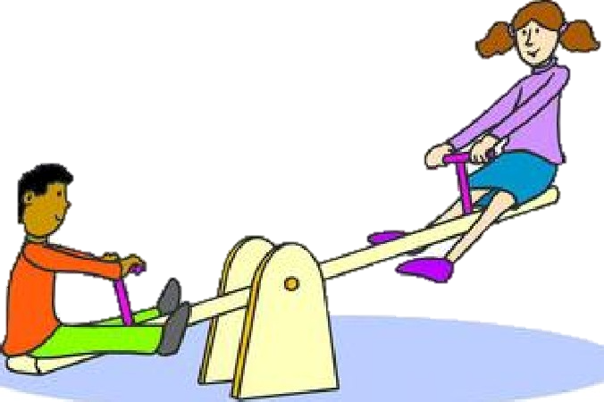

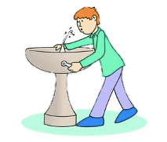
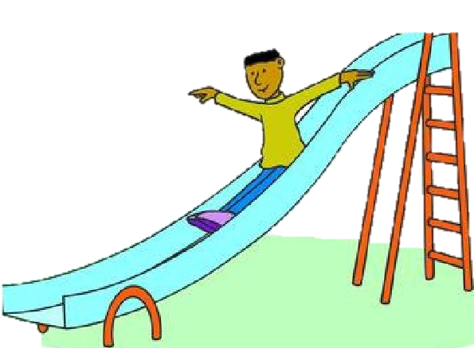
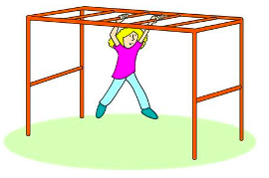
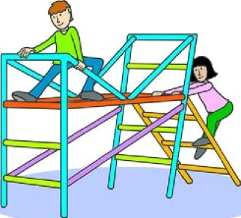
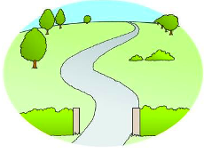

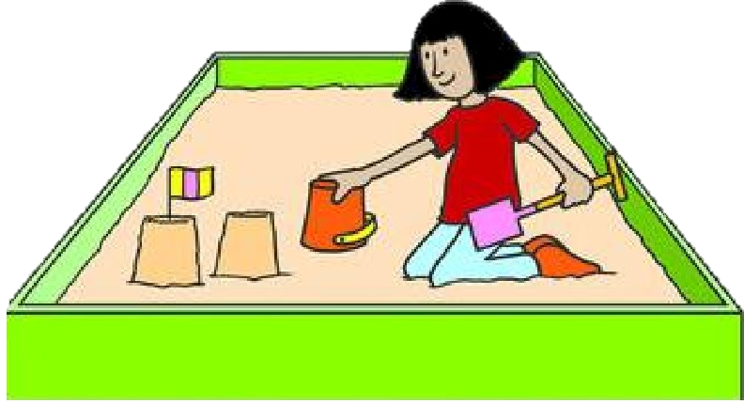

ANSWER KEY
MATCH THE PICTURE
9
7

1. slide
2.merry go round
3. seesaw
4. sandbox
5. path
6. monkey bar
7. playground
8. climbing frame
9. rope bridge
10. drinking fountain

3
2

1
4
10
5
6
8

