TOPIC: Nature | SUBTOPICS: Naming Nature | LEVEL: A1
Name: ____________________________ Surname: ____________________________ N^{ber}: ____ Grade/Class: _____

Find the words about playground
Look at the picture. Complete the missing words.
TOPIC: Playground | SUBTOPICS: Match the Nature | LEVEL: A1
Name: ____________________________ Surname: ____________________________ N^{ber}: ____ Grade/Class: _____
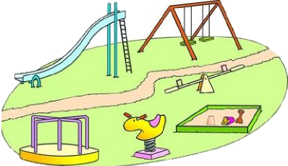

TOPIC: Playground | SUBTOPICS: Complete the words about Playground | LEVEL: A1
Name: ____________________________ Surname: ____________________________ N^{ber}: ____ Grade/Class: _____

Complete the words based on the picture.

1. s _ i _ e
2. _ _ e_ a_
3. _ w _ _ g
4. s_ r i _ _ y
5. me _ _ y g _ r o _ _ d

TOPIC: Playground | SUBTOPICS: Fill in the blanks about Playground | LEVEL: A1
Name: ____________________________ Surname: ____________________________ N^{ber}: ____ Grade/Class: _____

ANSWER KEY
Find the words about playground
Look at the picture. Complete the missing words.
TOPIC: Playground | SUBTOPICS: Match the Nature | LEVEL: A1
Name: ____________________________ Surname: ____________________________ N^{ber}: ____ Grade/Class: _____

TOPIC: Playground | SUBTOPICS: Complete the words about Playground | LEVEL: A1
Name: ____________________________ Surname: ____________________________ N^{ber}: ____ Grade/Class: _____

Complete the words based on the picture.
l d
1. s _ i _ e
s e s w
2. _ _ e_ a_
s i n
3. _ w _ _ g
p n g
4. s_ r i _ _ y
o u n
r r
5. me _ _ y g _ r o _ _ d

