Name: ____________________________ Surname: ____________________________ N^{ber}: ____ Grade/Class: _____
Assessment: _____________________________ | Date: ___________________________________________________
 | Teacher’s signature:  ___________________________ | Parent’s signature:  ___________________________

Listen and number.
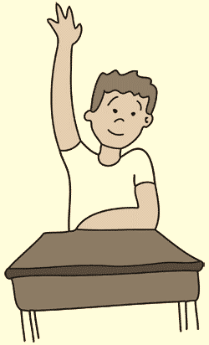
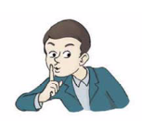
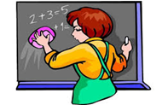

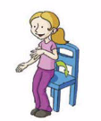
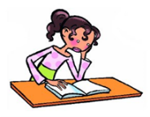

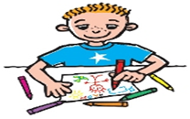
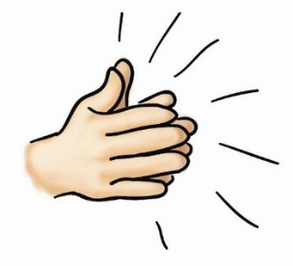

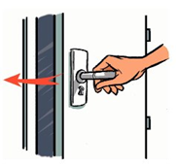
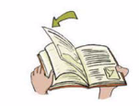

TRANSCRIPT
- Stand up
- Close the door
- Be quiet
- Clap your hands
- Clean the board
- Sit down
- Colour the picture
- Read the book
- Raise your hand
- Open the book

ANSWER KEY
- Stand up
- Close the door
- Be quiet
- Clap your hands
- Clean the board
- Sit down
- Colour the picture
- Read the book
- Raise your hand
- Open the book

