Name: ____________________________ Surname: ____________________________ N^{ber}: ____ Grade/Class: _____
Assessment: _____________________________  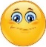  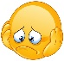 | Date: ___________________________________________________
 | Teacher’s signature:  ___________________________ | Parent’s signature:  ___________________________

- Listen and colour.

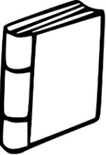
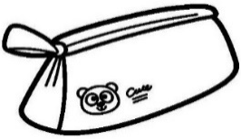

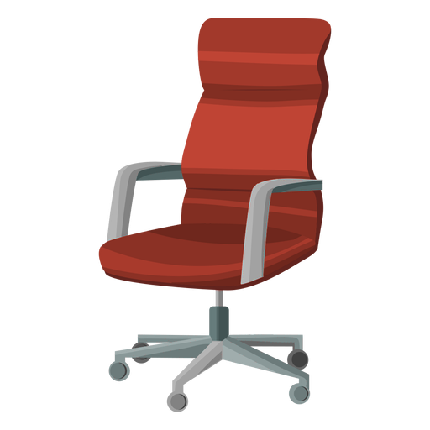

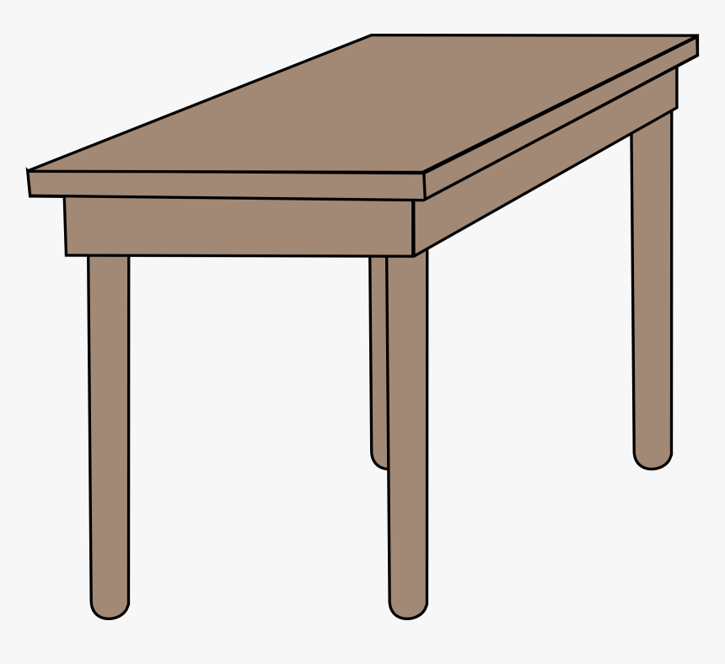

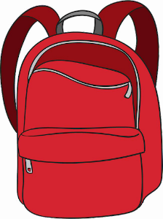

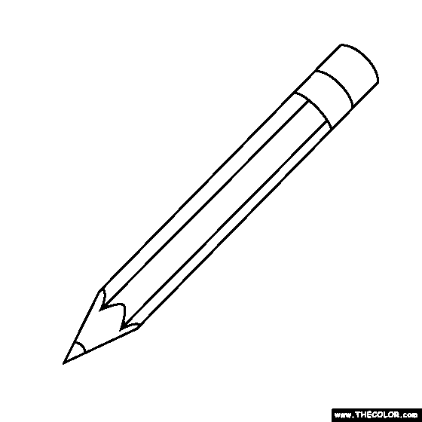

- Listen and link. There is one example.

TRANSCRIPT

EXERCISE 1

ONE
Can you see the book? The book is orange.
TWO
Can you see the pencil? The pencil is yellow.
THREE
Can you see the ruler? The ruler is blue.
FOUR
Can you see the pencil case? The pencil case is red.
FIVE
Can you see the rubber? The rubber is green.
SIX
Can you see the crayons? There are two crayons: one is pink and one is brown.

EXERCISE 2

ONE Example
The book is on the desk.
TWO
The pencil is under the chair.
THREE
The ruler is in the schoolbag.
FOUR
The pencil case is on the chair.
FIVE
The rubber is near the schoolbag.
SIX
The crayons are on the desk.

ANSWER KEY

EXERCISE 1
ONE - The book is orange.
TWO - The pencil is yellow.
THREE - The ruler is blue.
FOUR - The pencil case is red.
FIVE - The rubber is green.
SIX- Two crayons: one is pink and one is brown.

EXERCISE 2
ONE - The book is on the desk.
TWO - The pencil is under the chair.
THREE - The ruler is in the schoolbag.
FOUR - The pencil case is on the chair.
FIVE - The rubber is near the schoolbag.
SIX - The crayons are on the desk.

