Name: ____________________________ Surname: ____________________________ N^{ber}: ____ Grade/Class: _____
Assessment: _____________________________ | Date: ___________________________________________________
 | Teacher’s signature:  ___________________________ | Parent’s signature:  ___________________________

- Listen and colour.

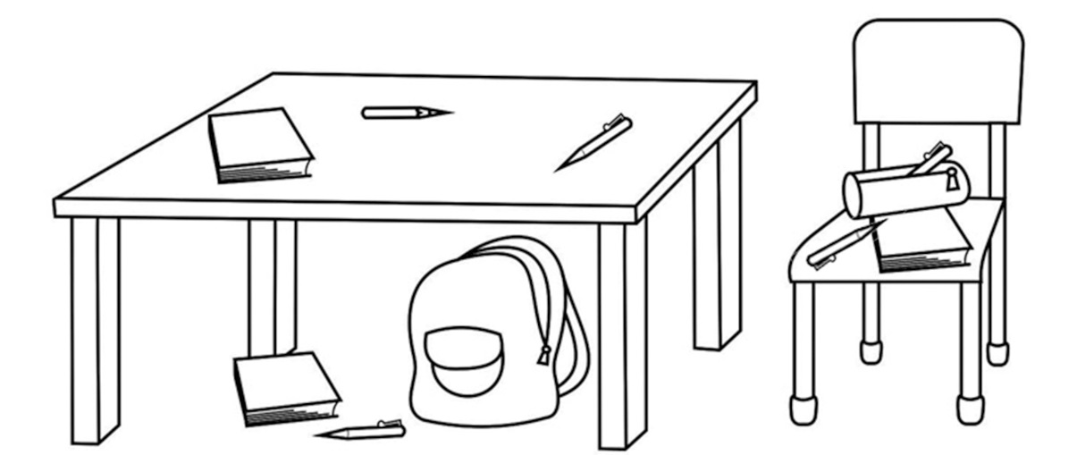

- Listen and number.

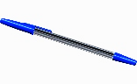
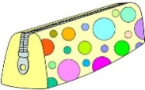
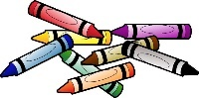
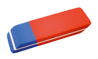

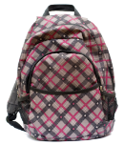

TRANSCRIPT

EXERCISE 1

ONE
Look at the picture. Can you see the pen on the desk?
Colour it red. A red pen on the desk.
TWO
Can you see the book on the chair?
Colour it brown. A brown book on the chair.
THREE
Can you see the pen under the desk?
Colour it yellow. A yellow pen under the desk.
FOUR
Can you see the pen in the pencil case?
Colour it green. A green pen in the pencil case.
FIVE
Can you see the pen on the chair?
Colour it orange. An orange pen on the chair.

EXERCISE 2

- Pen
- Pencil case
- Schoolbag
- Glue
- Book
- Crayons
- Notebook
- Scissors
- Pencil
- Pencil sharpener
- Rubber
- Ruler

ANSWER KEY

EXERCISE 1:
ONE - Red pen on the desk
TWO - Brown book on the chair
THREE- Yellow pen under the desk
FOUR - Green pen in the pencil case
FIVE - Orange pen on the chair

EXERCISE 2
- Pen
- Pencil case
- Schoolbag
- Glue
- Book
- Crayons
- Notebook
- Scissors
- Pencil
- Pencil sharpener
- Rubber
- Ruler

