Name: ____________________________ Surname: ____________________________ N^{ber}: ____ Grade/Class: _____
Assessment: _____________________________ | Date: ___________________________________________________
 | Teacher’s signature:  ___________________________ | Parent’s signature:  ___________________________

- Read the text.

Hello, my name’s Mike Williams and I’m nine years old. My birthday is in September.
I’m a student. I’m in class 3B. I like reading and drawing.
My teacher is Mrs Jones, I love my teacher.
Look! I’ve got my schoolbag it is blue and red. In my schoolbag I have my book, my notebook, my pencil case and my coloured pencils. I haven’t got my ruler.

2) Complete.
IDENTIFICATION CARD
Name: __________________ Surname: ________________________
Age: ____________________ Month of birthday: ________________
Class: ___________________ Teacher: ________________________

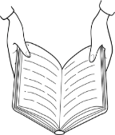
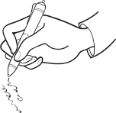
3) Tick ( ) the school activities Mike likes.
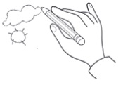

4) Look this is Jack’s schoolbag. Draw the school objects he has.

ANSWER KEY

EXERCISE 2
Name: Mike
Surname: Williams
Age: nine
Month of birthday: September
Class: 3B
Teacher: Mrs Jones

EXERCISE 3
Tick: reading / drawing

EXERCISE 4
Book; notebook; pencil case; coloured pencils; ruler

