Name: ____________________________ Surname: ____________________________ N^{ber}: ____ Grade/Class: _____
Assessment: _____________________________  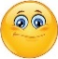  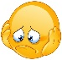 | Date: ___________________________________________________
 | Teacher’s signature:  ___________________________ | Parent’s signature:  ___________________________

Read and look. Put a tick ( ) or a cross ( ).

1) I’ve got a pencil, a ruler and a rubber.
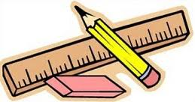

2) Can I sharpen my pencil case?

3) The book is on the schoolbag.
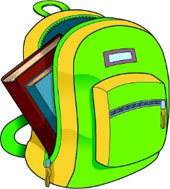

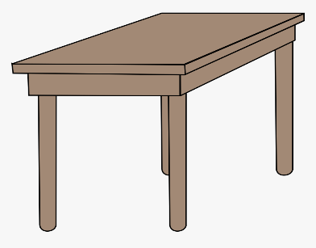
4) The scissors are under the desk.

5) They are drawing.

6) There are two pencils in the pencil case.
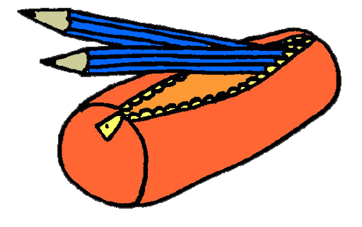

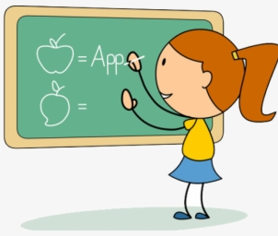
7) The girl is writing on the board.

8) Can I go to the toilet?
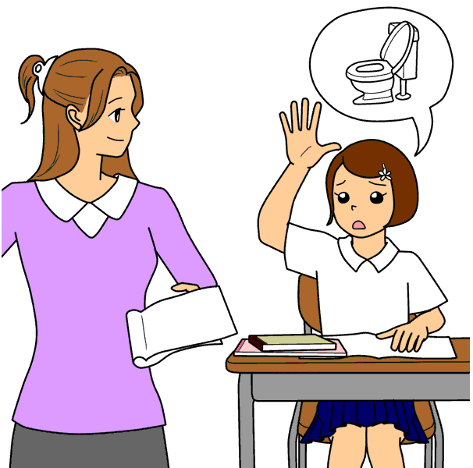

ANSWER KEY

- Tick
- Tick
- Cross
- Cross
- Cross
- Tick
- Tick
- Tick

