Name: ____________________________ Surname: ____________________________ N^{ber}: ____ Grade/Class: _____
Assessment: _____________________________ | Date: ___________________________________________________
 | Teacher’s signature:  ___________________________ | Parent’s signature:  ___________________________

STUDENT A
- Look at your schoolbag.
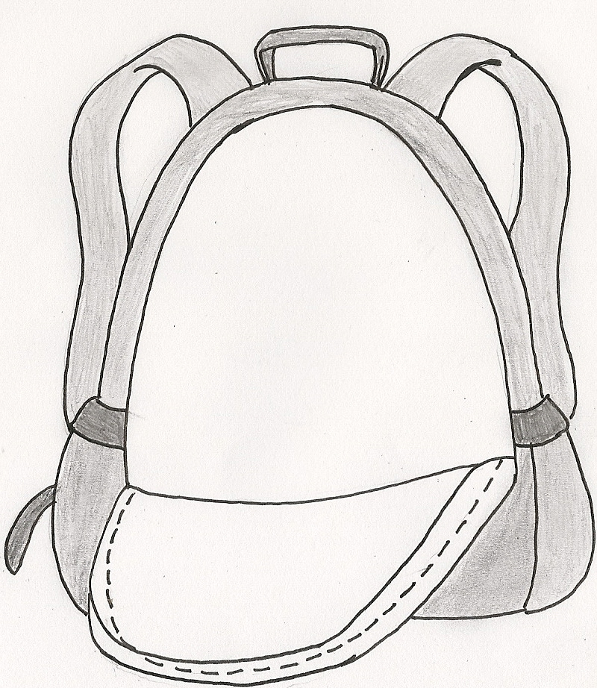
Answer your partners’ questions.

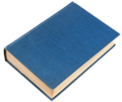

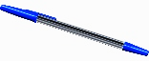

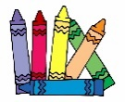

- Ask your partner: “Have you got …?”
Put a tick ( ) or a cross ( ).

 | 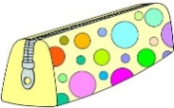 |  | 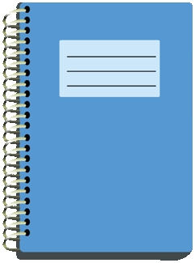 |  | 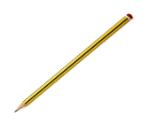
My partner’s schoolbag

Name: ____________________________ Surname: ____________________________ N^{ber}: ____ Grade/Class: _____
Assessment: _____________________________ | Date: ___________________________________________________
 | Teacher’s signature:  ___________________________ | Parent’s signature:  ___________________________
STUDENT B
- Ask your partner: “Have you got …?”
Put a tick ( ) or a cross ( ).

 |  |  | 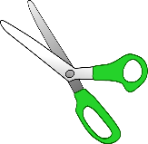 |  | 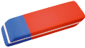 | 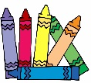
My partner’s schoolbag

- Look at your schoolbag.
Answer your partners’ questions.

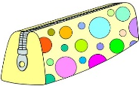

ANSWER KEY
STUDENT B | STUDENT A
Have you got a book? | Yes, I have.
Have you got a pen? | Yes, I have.
Have you got scissors? | No, I haven´t.
Have you got glue? | Yes, I have.
Have you got a rubber? | No, I haven´t.
Have you got crayons? | No, I haven´t.

STUDENT A | STUDENT B
Have you got a pencil case? | Yes, I have.
Have you got a pencil sharpener? | No, I haven´t.
Have you got a notebook? | Yes, I have.
Have you got a ruler? | No, I haven´t.
Have you got a pencil? | Yes, I have.
Have you got coloured pencils? | No, I haven´t.

