Name: ____________________________ Surname: ____________________________ N^{ber}: ____ Grade/Class: _____
Assessment: _____________________________ | Date: ___________________________________________________
 | Teacher’s signature:  ___________________________ | Parent’s signature:  ___________________________

STUDENT A

- Look at the pictures.
Give 6 instructions to your partner.
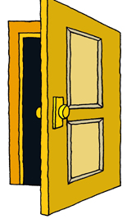

1, 2, 3….
8, 9, 10

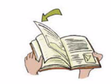
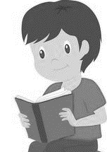

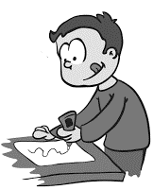
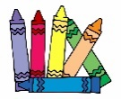
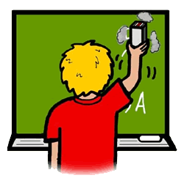
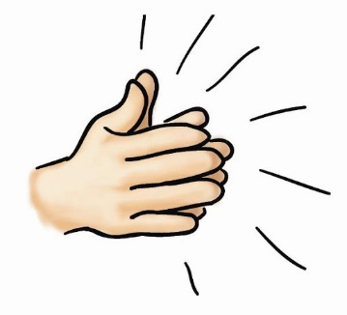

- Respond to your partner’s instructions.

Name: ____________________________ Surname: ____________________________ N^{ber}: ____ Grade/Class: _____
Assessment: _____________________________ | Date: ___________________________________________________
 | Teacher’s signature:  ___________________________ | Parent’s signature:  ___________________________
STUDENT B

- Respond to your partner’s instructions.

- Look at the pictures.
Give 6 instructions to your partner.
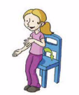
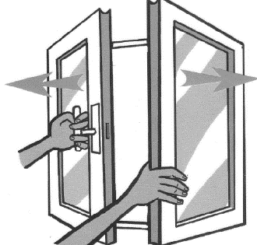
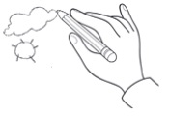

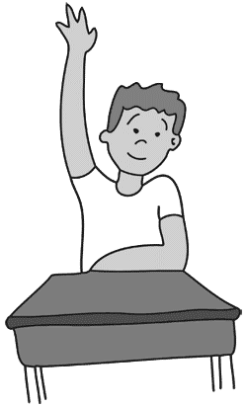
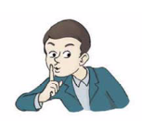
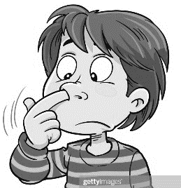

ANSWER KEY

STUDENT A
Listen.
Close the door.
Count to 10.
Read.
Open the book.
Stand up.
Clap your hands.
Glue the picture.
Clean the board.

STUDENT B
Open the window.
Draw a cloud.
Sit down.
Be quiet.
Cut the paper.
Write.
Close the book.
Raise your hand.
Point to your nose.

