Name: ____________________________ Surname: ____________________________ N^{ber}: ____ Grade/Class: _____
Assessment: _____________________________ | Date: ___________________________________________________
 | Teacher’s signature:  ___________________________ | Parent’s signature:  ___________________________

Look at the picture.
Answer the questions.

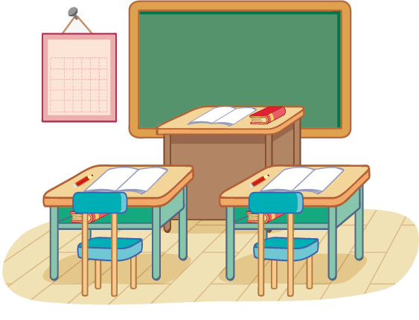
Monday, 6th October

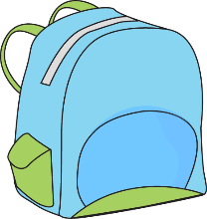
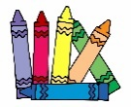

TEACHER’S QUESTIONS:

- Point to the board / chair / book.
- What’s this? desk; schoolbag; pencil
- Who’s this? teacher; student
- What is the day of the week?
- What colour is this schoolbag? / the ruler? / What colour are the desks? / the books?
- Where is the rubber? / the pencil sharpener? / the ruler? / the blue schoolbag?
- How many students are there? / How many notebooks are there?

ANSWER KEY
- The student points to the objects: board, chair, desk.
- The student identifies the object: desk, schoolbag, pencil.
- The student identifies the teacher and one student.
- It’s Monday.
- The school bag is blue / green.
The ruler is yellow.
The desks are brown.
The books are red.
- The rubber is on the desk.
The pencil sharpener is under the desk.
The ruler is in the school bag.
The blue school bag is near the desk.
- There are two students.
There are three notebooks.

