|  |  |  |
| --- | --- | --- |
| **Name:** ____________________________ **Surname:** ____________________________ **Nber: ____ Grade/Class:** _____ | | |
| **Assessment:** _____________________________ | **Date:** ___________________________________________________ | |
| **Teacher’s signature:**  **___________________________** | **Parent’s signature:**  **___________________________** |

**Look at the pictures. Mime school activities.**

**Teacher:** *What are you doing?*

**Student:** *I’m…*

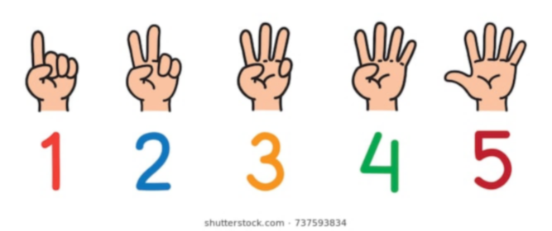

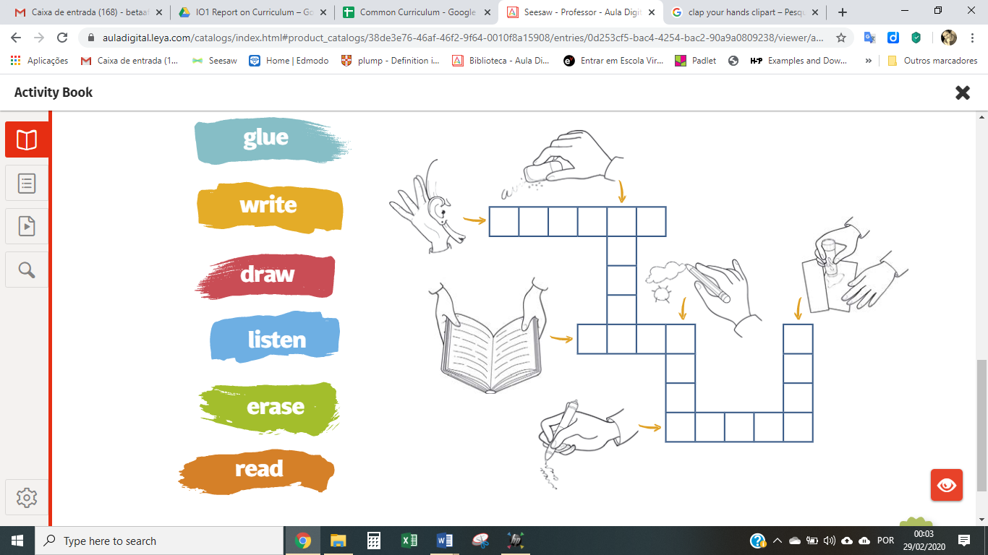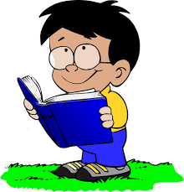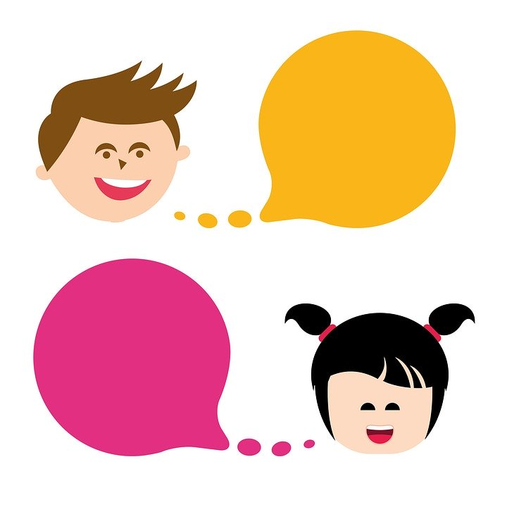

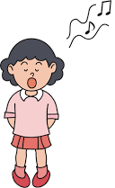

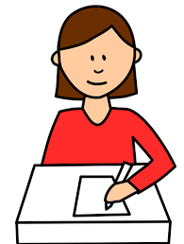

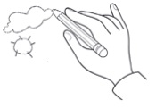

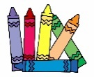

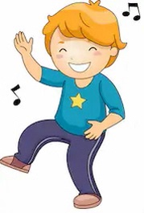

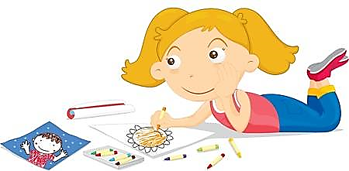

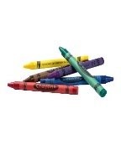

**KEY ANSWER**

**Teacher**:

* What are you doing?

**Student**:

* I’m reading;
* I’m listening;
* I’m counting;
* I’m drawing;
* I’m writing;
* I’m singing;
* I’m dancing;
* I’m colouring.