Name: ____________________________ Surname: ____________________________ N^{ber}: ____ Grade/Class: _____
Assessment: _____________________________ | Date: ___________________________________________________
 | Teacher’s signature:  ___________________________ | Parent’s signature:  ___________________________

STUDENT A
- Ask your partner: “Where is/are the…?”. Draw the lines.
Example: Student A : Where is the pencil?
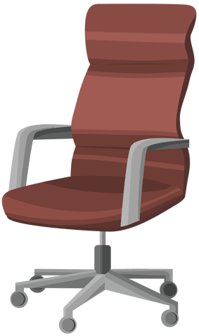
Student B: It is on the desk.

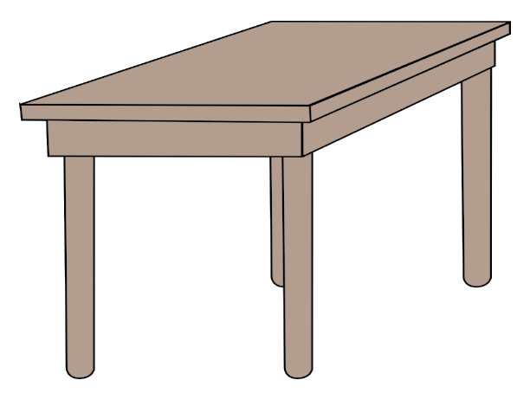
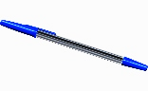

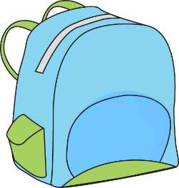

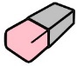

- Look. Answer your partner’s questions.
Example: Student B: Where is the pencil?
Student A: It is on the desk.
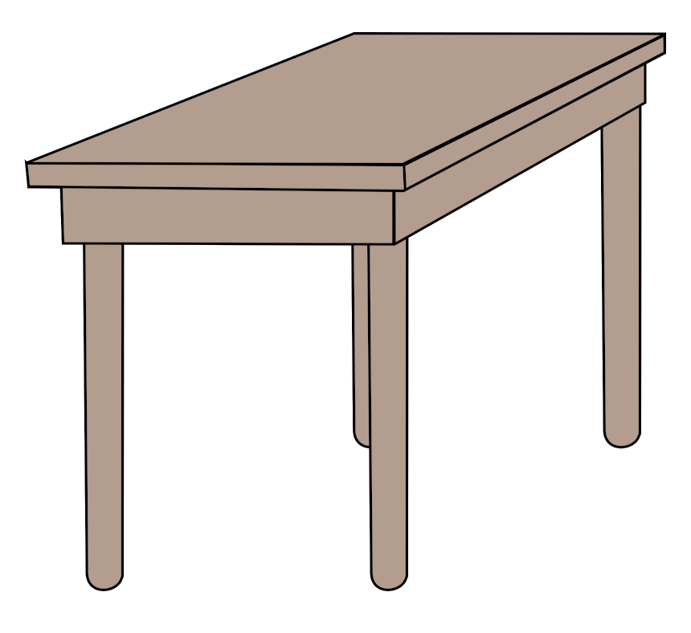

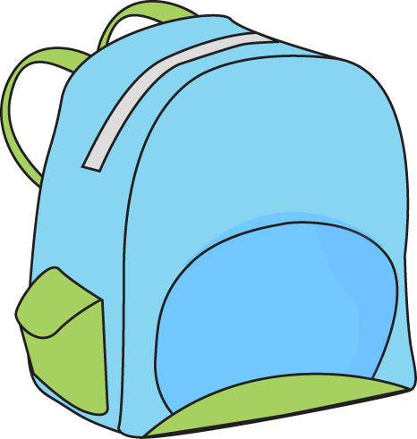
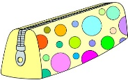

Name: ____________________________ Surname: ____________________________ N^{ber}: ____ Grade/Class: _____
Assessment: _____________________________ | Date: ___________________________________________________
 | Teacher’s signature:  ___________________________ | Parent’s signature:  ___________________________

STUDENT B
- Look. Answer your partner’s questions.
Example: Student A: Where is the pencil?
Student B: It is on the desk.
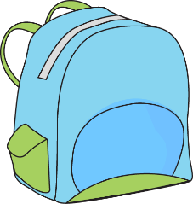

- Ask your partner: “Where is/are the…?”. Draw the lines.
Example: Student B : Where is the pencil?
Student A: It is on the desk.

ANSWER KEY
STUDENT A | STUDENT B
Where is the pen? | It is under the desk.
Where are the scissors? | They are in the school bag.
Where is the book? | It is on the chair.
Where is the rubber? | It is near the chair.

STUDENT B | STUDENT A
Where is the ruler? | It is in the school bag
Where are the books? | They are on the desk.
Where are the pencil sharpener? | It is under the chair.
Where is the pencil case? | It is near the chair.

