Name: ____________________________ Surname: ____________________________ N^{ber}: ____ Grade/Class: _____
Assessment: _____________________________  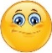 | Date: ___________________________________________________
 | Teacher’s signature:  ___________________________ | Parent’s signature:  ___________________________

Classroom language
Circle the correct answer to label the pictures.

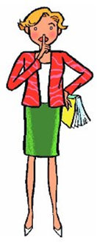
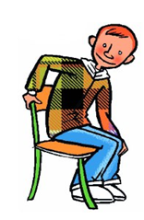
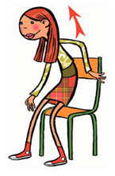
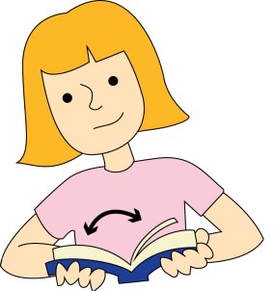
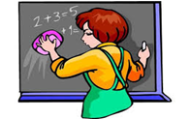

Stand up
Sit down
Be quiet
Read
Be quiet
Listen
Write
Draw
Open your book
Open the window
Clean the board
Pay attention
Sit down
Raise your hand
Clap your hands

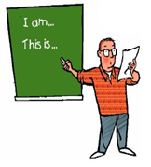
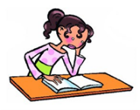
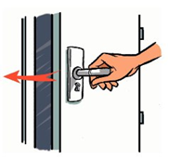
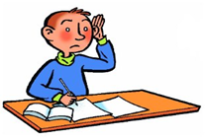
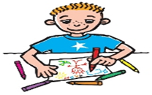

Look at the board
Clean the board
Point to your nose
Open the book
Close the door
Close the window
Cut the paper
Glue the picture
Colour the picture
Colour
Draw
Read
Listen
Count
Sing

ANSWER KEY
Stand up
Be quiet
Open your book
Clean the board
Sit down
Close the door
Listen
Colour the picture
Read
Look at the board

