Name: ____________________________ Surname: ____________________________ N^{ber}: ____ Grade/Class: _____
Assessment: _____________________________ | Date: ___________________________________________________
 | Teacher’s signature:  ___________________________ | Parent’s signature:  ___________________________

- Complete with the words in the box.
Thursday
Tuesday
Wednesday
Sunday
Friday
Monday
Saturday

Days of the week
Weekend
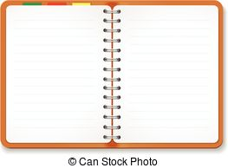

Monday
__________________
__________________
____________________
____________________
S_________________
S_________________

- Complete with the months of the year.
m
e
O
t
S
u
J
m
i
p
c
y
F
u
b
a
a

Which month is missing? __ __ __ __ __ __ __ __ is missing!
ANSWER KEY

EXERCISE 1:
Monday
Tuesday
Wednesday
Thursday
Friday
Saturday
Sunday

EXERCISE 2:
- January
- February
- March
- April
- Mai
- June
- July
- August
- September
- October
- November
December is missing

