TOPIC: School | SUBTOPICS: school material; prepositions in, on, under, near | LEVEL: A1
Name: ____________________________ Surname: ____________________________ N^{ber}: ____ Grade/Class: _____

1. Read, look and write.

a schoolbag a desk a pen a pencil a chair a rubber a book a pencil case

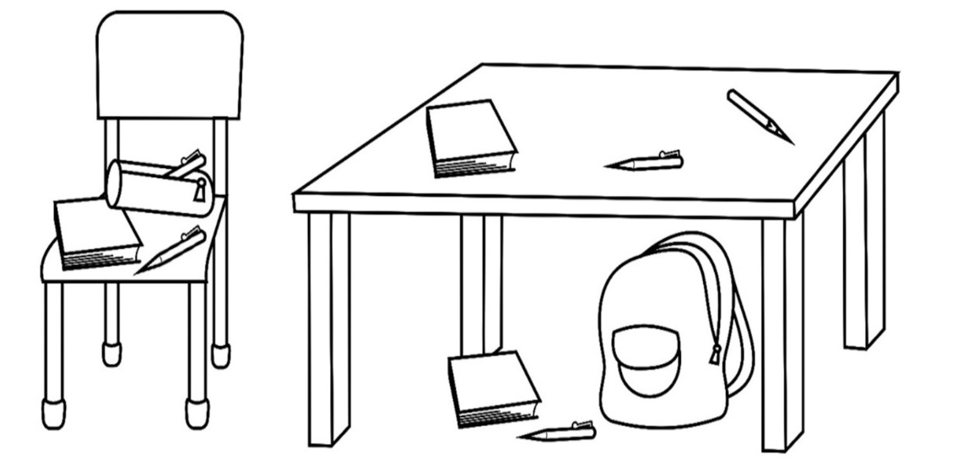

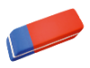

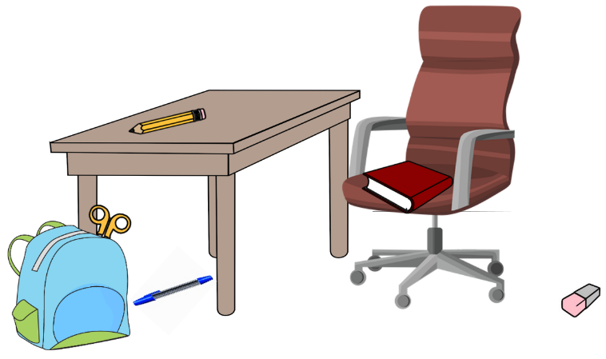
2. Circle the correct answer.

a. The pen is under / in the desk.
b. The rubber is near / on the chair.
c. The scissors are near / in the schoolbag.
d. The book is under / on the chair.

