|  |  |  |
| --- | --- | --- |
| **TOPIC: School** | **SUBTOPICS: school material; colours; prepositions *in, on, under, near*** | **LEVEL: A1** |
| **Name:** \_\_\_\_\_\_\_\_\_\_\_\_\_\_\_\_\_\_\_\_\_\_\_\_\_\_\_\_ **Surname:** \_\_\_\_\_\_\_\_\_\_\_\_\_\_\_\_\_\_\_\_\_\_\_\_\_\_\_\_ **Nber: \_\_\_\_ Grade/Class:** \_\_\_\_\_ | | |

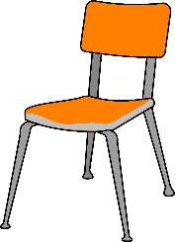**1. Match.**

**9**

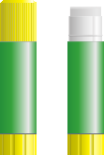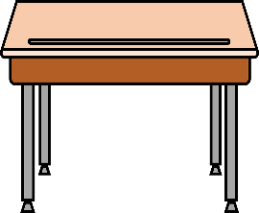

Chair

Desk

Glue

Pen

Ruler

Pencil

Book

Rubber

Crayons

Coloured pencils

Pencil case

School bag

Pencil sharpener

Scissors

**2**

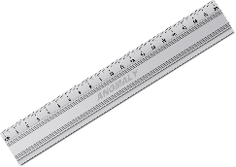

**10**

**1**

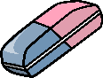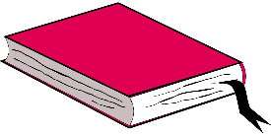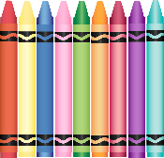

**11**

**4**

**3**

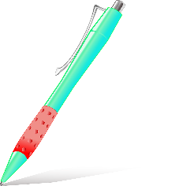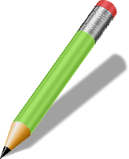

**12**

**5**

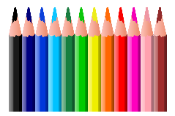

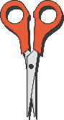

**13**

**6**

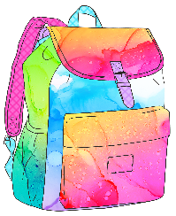

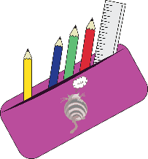

**7**

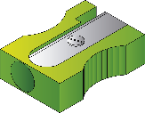

**14**

**8**

**2. Read and draw. Then colour.**

a red pencil sharpener

two green pens

a yellow pencil case

blue scissors

**3. Look and write.**

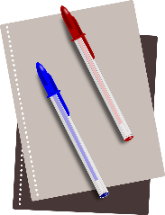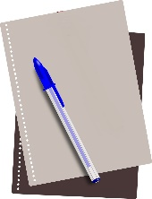

The pens **are** on

the notebook.

The pen **is** on

the notebook.

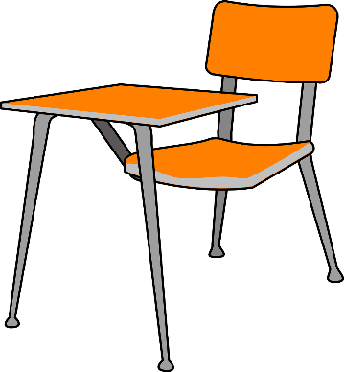

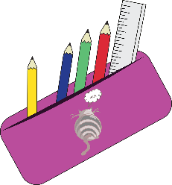

C:\Users\betaa\OneDrive\Ambiente de Trabalho\ASSESS_FreePictures\_SCHOOL\School Objects-Material\rubber.eraser.png

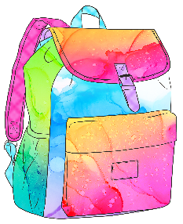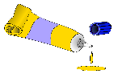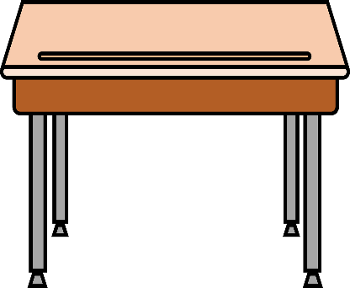

The \_\_\_\_\_\_\_\_\_\_\_\_\_\_\_\_\_ \_\_\_\_\_\_ \_\_\_\_\_\_

the \_\_\_\_\_\_\_\_\_\_\_\_\_\_\_\_\_.

The \_\_\_\_\_\_\_\_\_\_\_\_\_\_\_\_\_ \_\_\_\_\_\_ \_\_\_\_\_\_

the \_\_\_\_\_\_\_\_\_\_\_\_\_\_\_\_\_.

The \_\_\_\_\_\_\_\_\_\_\_\_\_\_\_\_\_ \_\_\_\_\_\_ \_\_\_\_\_\_

the \_\_\_\_\_\_\_\_\_\_\_\_\_\_\_\_\_.

The \_\_\_\_\_\_\_\_\_\_\_\_\_\_\_\_\_ \_\_\_\_\_\_ \_\_\_\_\_\_

the \_\_\_\_\_\_\_\_\_\_\_\_\_\_\_\_\_.