Name: ____________________________ Surname: ____________________________ N^{ber}: ____ Grade/Class: _____
Assessment: _____________________________ | Date: ___________________________________________________
 | Teacher’s signature:  ___________________________ | Parent’s signature:  ___________________________

Look and complete.
Yes, No,
I
have haven’t

Have you got a pencil?

________ , ______ __________

Have you got a pencil sharpener?

________ , ______ __________

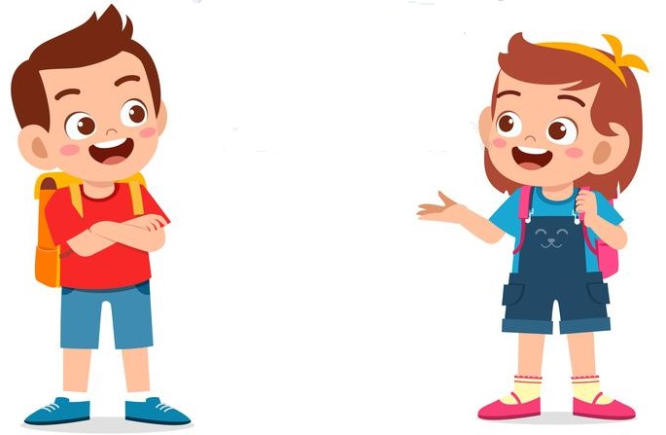
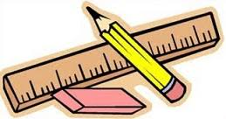
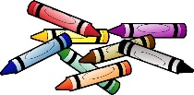
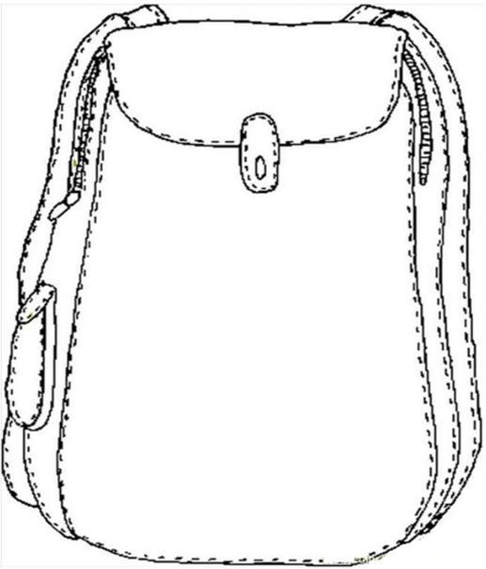
________ , ______ __________
________ , ______ __________
Have you got crayons?
Have you got scissors?

ANSWER KEY
Yes, I have.
No, I haven’t.
No, I haven’t.
Yes, I have.

