Name: ____________________________ Surname: ____________________________ N^{ber}: ____ Grade/Class: _____
Assessment: _____________________________  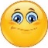  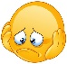  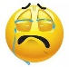 | Date: ___________________________________________________
 | Teacher’s signature:  ___________________________ | Parent’s signature:  ___________________________

1) Fill in the gaps.

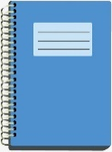
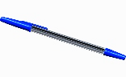
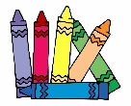
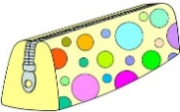
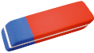

__u b__ __r p__ __ n__ __ __ b__ __k __e__c__l c__s__ c__ __y__ n__

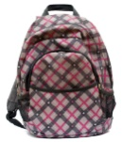
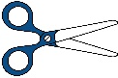
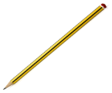

__lu__ sc__ __ol __ __g p__ __c__l r__l__r sc__ ss __ __s

__ __a__d b__ __ c__ m __ u __ __r

2) Circle the correct answer.

a. The pencil is in / under the chair.
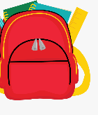
b. The book is on / under the desk.
c. The ruler is near / in the schoolbag.
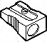
d. The pencil sharpener is near / on the desk.

ANSWER KEY

EXERCISE 1:
rubber; pen; notebook; pencil case; crayons; glue; school bag; pencil; ruler; scissors; board; bin; computer

EXERCISE 2:
- Under
- On
- In
- near

