|  |  |  |
| --- | --- | --- |
| **Name:** ____________________________ **Surname:** ____________________________ **Nber: ____ Grade/Class:** _____ | | |
| **Assessment:** _____________________________ | **Date:** ___________________________________________________ | |
| **Teacher’s signature:**  **___________________________** | **Parent’s signature:**  **___________________________** |

**Read the classroom instructions and match the pictures.**

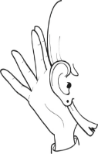

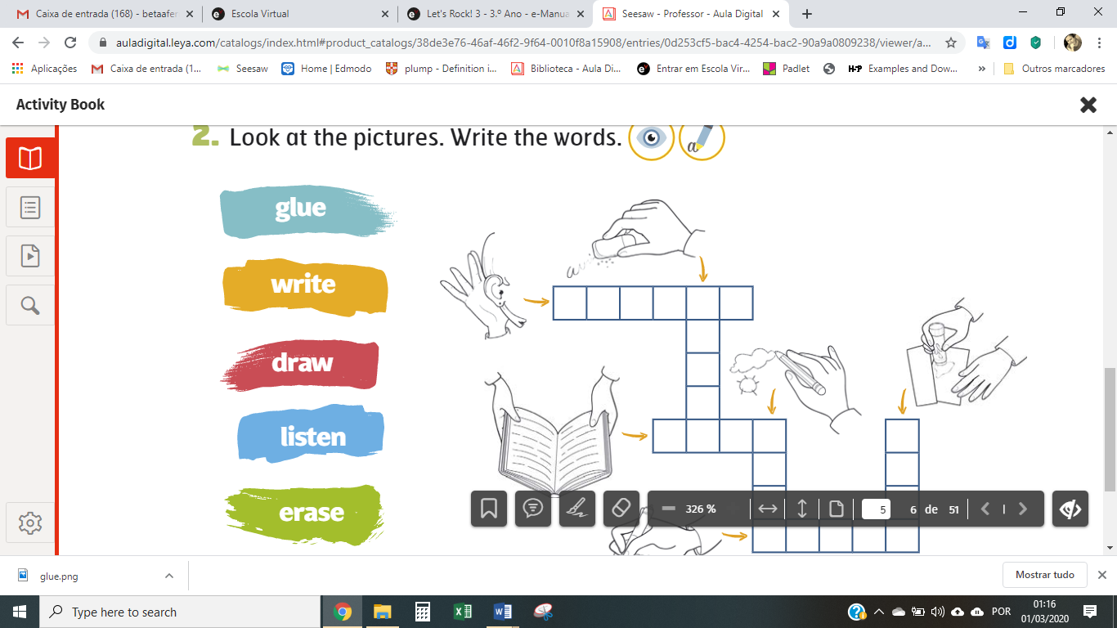

1. Listen
2. Read
3. Raise your hand
4. Write
5. Erase
6. Draw a cloud
7. Count to 10
8. Cut the paper
9. Glue the picture
10. Stand up
11. Sit down
12. Open the book
13. Close the book
14. Be quiet

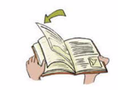

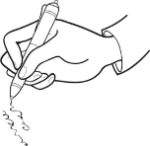

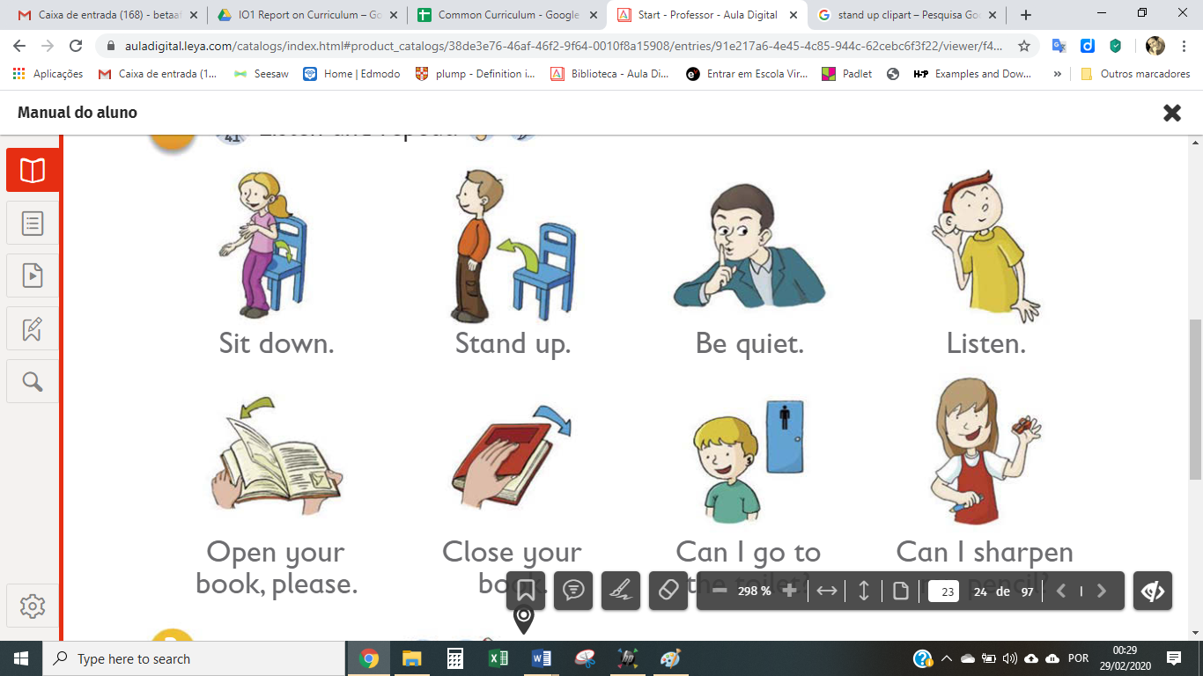

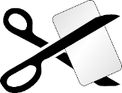

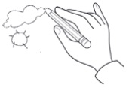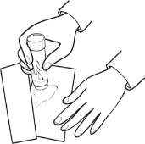

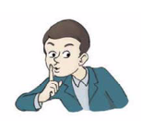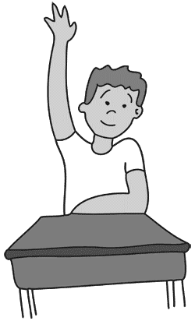



G E  
U L

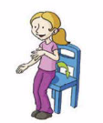

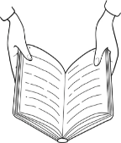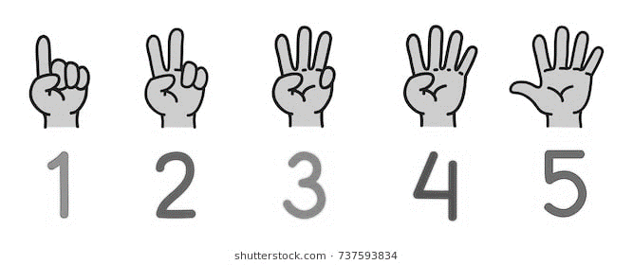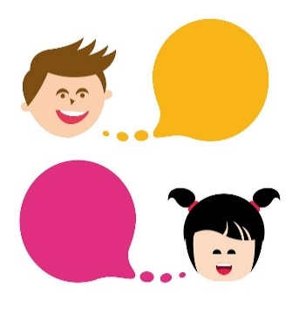

**ANSWER KEY**





5

1





12

4





8

13



9

6



14

11

3

10



G E  
U L





7

2

