TOPIC: School | SUBTOPICS: where is…/are… ?; school objects; prepositions of place: in, on, under, near | LEVEL: A1
Name: ____________________________ Surname: ____________________________ N^{ber}: ____ Grade/Class: _____
Where is… ? Where are… ?

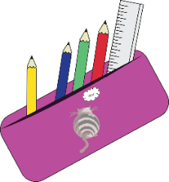
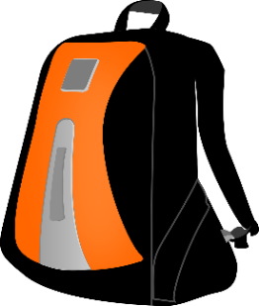
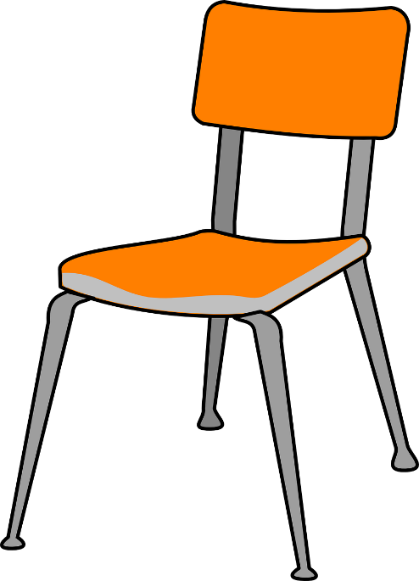

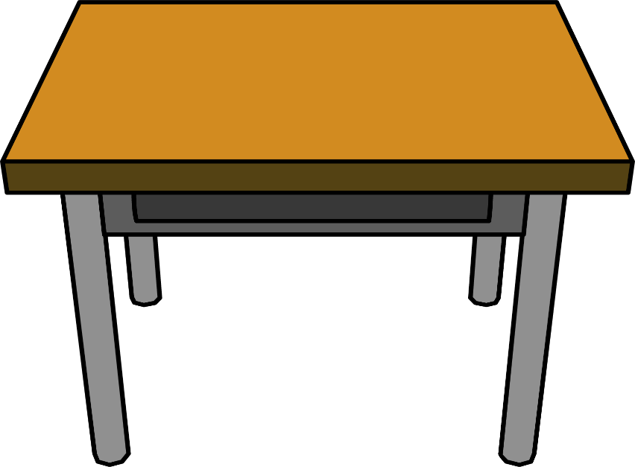

Look at the picture and answer the questions.
in
on
under
near
- It is _________ the desk.
- They are _________ the pencil case.
- It is _________ the chair
- It is _________ the desk
- They are _________ the c __ i __.
- It is _________ the p__ __ c __ __ c__ __ __.
- It _____ ____________ the _______________.
- They _____ ___________ the _______________.

a) Where is the computer?
b) Where are the crayons?
c) Where is the schoolbag?
d) Where is the pencil sharpener?
e) Where are the books?
f) Where is the ruler?
g) Where is the rubber?
h) Where are the scissors?

