TOPIC: School | SUBTOPICS: school objects, colours | LEVEL: A1
Name: ____________________________ Surname: ____________________________ N^{ber}: ____ Grade/Class: _____

Colouring School objects

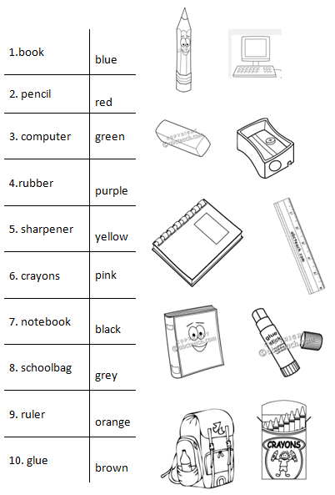
Colour.

