TOPIC: School | SUBTOPICS: School objects; How many…? There is/are…; Numbers | LEVEL: A1
Name: ____________________________ Surname: ____________________________ N^{ber}: ____ Grade/Class: _____
How many…? - There is/are…

Answer the questions.
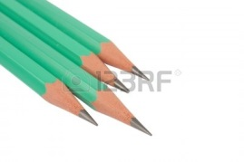
- How many pencils are there?
_____________________
- How many books are there?

_____________________

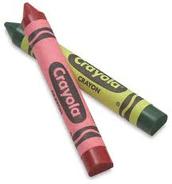
- How many crayons are there?

______________________

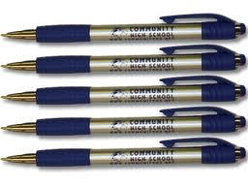
- How many pens are there?

________________________

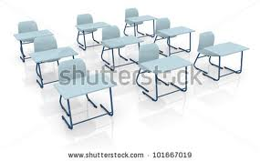
- How many desks are there?

_______________________

