TOPIC: School | SUBTOPICS: school objects | LEVEL: A1
Name: ____________________________ Surname: ____________________________ N^{ber}: ____ Grade/Class: _____

School objects

Look and write.

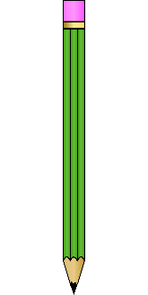

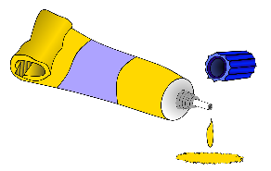

c p i n e l | b u r b e r | l u e g | k o b o
__________________ | __________________ | __________________ | __________________

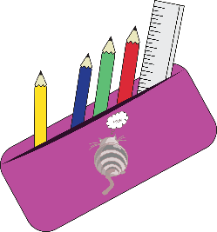
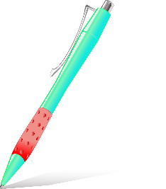

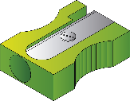

n e p | n e p l i c p e s h n e a r r | c p e n i l s e a c | s o s r c i s s
__________________ | __________________ | __________________ | __________________
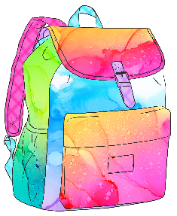
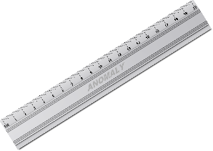

b s g c a o l o h | y c r n s a o | r e l u r | c r o o e l u d c p e n i l
__________________ | __________________ | __________________ | __________________

