Name: ____________________________ Surname: ____________________________ N^{ber}: ____ Grade/Class: _____
Assessment: _____________________________  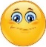 | Date: ___________________________________________________
 | Teacher’s signature:  ___________________________ | Parent’s signature:  ___________________________

- What are they doing? Look at the pictures and write.
I’m…
He’s…
They’re…
She’s…

…a song.
…a boy.
…my name.
…a book.
…reading…
…writing…
…drawing…
…singing…

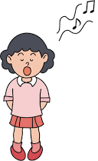
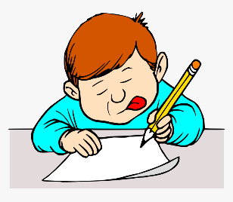
…..

a) ____________________________________ b) ____________________________________
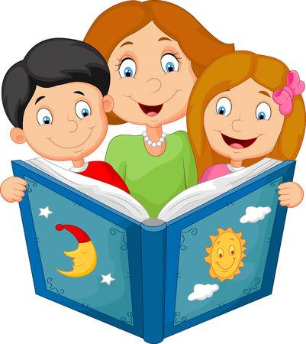
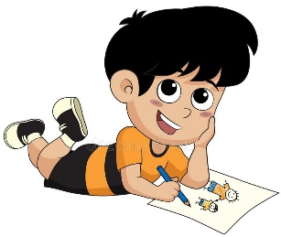

c) _____________________________________ d) _____________________________________

2) Put the words in order.
a) are / a picture / colouring / The students / . ____________________________________________
b) counting / The teacher / to 10 / is / . ____________________________________________
ANSWER KEY

1)
a) I’m writing my name.
b) She’s singing a song.
c) He’s drawing a boy.
d) They’re reading a book.

2)
a) The students are colouring a picture.
b) The teacher is counting to 10.

