Name: ____________________________ Surname: ____________________________ N^{ber}: ____ Grade/Class: _____
Assessment: _____________________________ | Date: ___________________________________________________
 | Teacher’s signature:  ___________________________ | Parent’s signature:  ___________________________

- Fill in the gaps.

friend teacher Hi! book class eight Bye schoolbag blue crayons

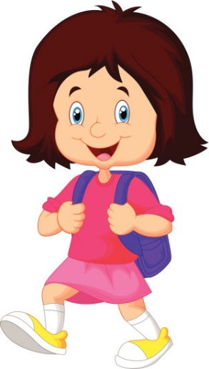
(1) _______________ I’m Melissa and I’m (2) ______________ years old.
I’m in (3) ________________ 3A with my (4) ________________ Jenny. My (5) ________________ is Mr Smith. He is a good teacher.
Look! My schoolbag is (6) ________________. It’s my favourite colour.
In my (7) ________________ I have my English (8) ________________, my pencil case and my (9) ________________.
(10) ______________!

2) Put the words in order.
a) singing / I like / and / dancing / . ____________________________________________
b) Can I / my / sharpen / pencil / . ____________________________________________
c) toilet / Can I / the / go to / . ____________________________________________

ANSWER KEY

1)
1. Hi
2. eight
3. class
4. friend
5. teacher
6. blue
7. schoolbag
8. book
9. crayons
10. Bye

2)
a) I like dancing and singing.
b) Can I sharpen my pencil?
c) Can I go to the toilet?

