Name: ____________________________ Surname: ____________________________ N^{ber}: ____ Grade/Class: _____
Assessment: _____________________________ | Date: ___________________________________________________
 | Teacher’s signature:  ___________________________ | Parent’s signature:  ___________________________

- What is in your schoolbag? Draw and colour 6 school objects.
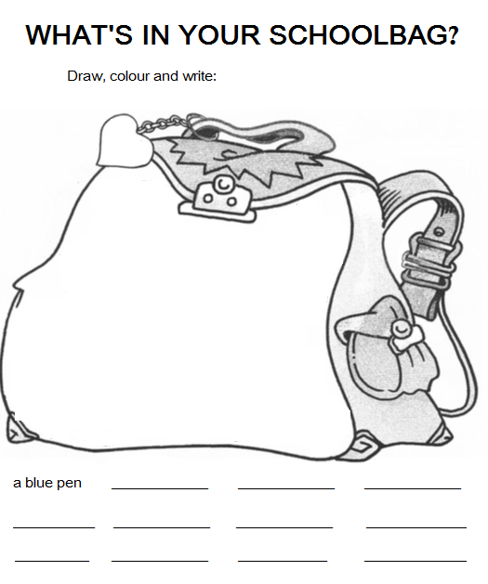

- Write.
In my schoolbag, I have a black notebook, ___________________________________________
______________________________________________________________________________
______________________________________________________________________________

ANSWER KEY
In my schoolbag, I have a black notebook, e red pencil case, two green books, coloured pencils, a blue ruler, a pink folder and yellow scissors.

