TOPIC: School | SUBTOPICS: in the classroom; school objects | LEVEL: A1
Name: ____________________________ Surname: ____________________________ N^{ber}: ____ Grade/Class: _____

In the classroom…

Look at the picture and answer the questions.

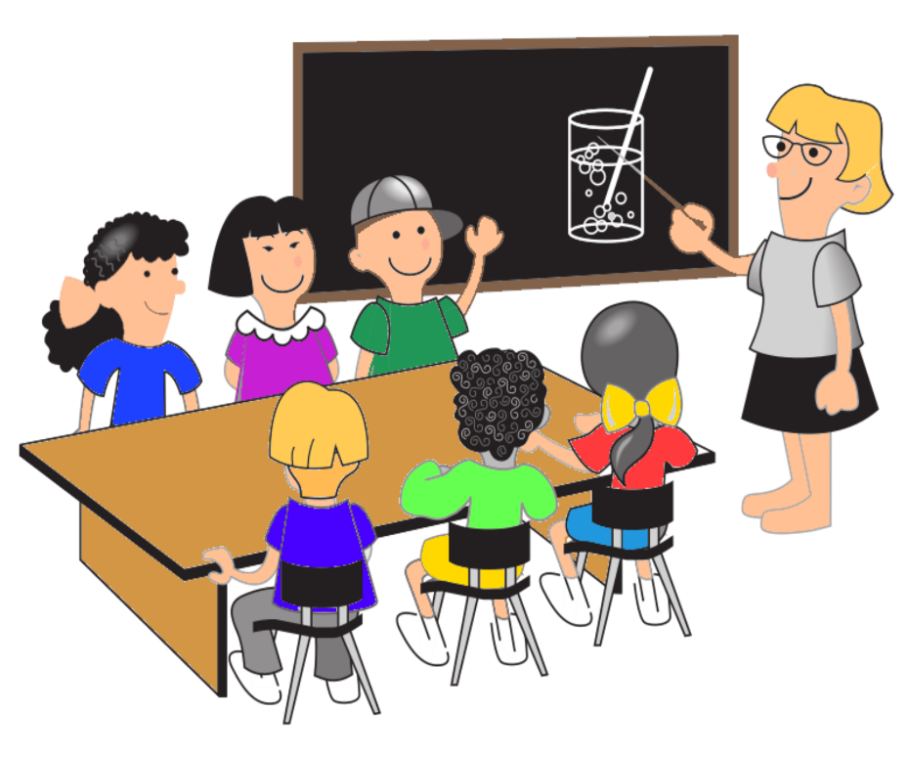
Monday, 6th October

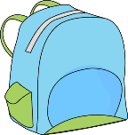

They are in the _______________
It’s _________________________
It’s _________________________
There are ____________ students.
It’s on the ___________________
It’s _________________________
It’s a ________________________

- Where are the students?
- What is the day of the week?
- What is the month of the year?
- How many students are there?
- Where is the teacher’s book?
- What colour is the board?
- What is in the schoolbag?

