Name: ____________________________ Surname: ____________________________ N^{ber}: ____ Grade/Class: _____
Assessment: _____________________________ | Date: ___________________________________________________
 | Teacher’s signature:  ___________________________ | Parent’s signature:  ___________________________

Look at the picture and read the questions. Write one word.

Wednesday, 10th October

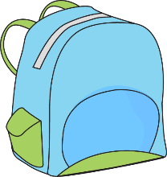

___________________
___________________
_______the desk
A __________________
A __________________
_______ the chair.

- What is the day of the week?
- How many books are there?
- Where are the books?
- What is on the chair?
- What is in the schoolbag?
- Where is the pencil?

ANSWER KEY

- Wednesday
- Two
- On
- Pencil sharpener
- Ruler
- Under

