Name: ____________________________ Surname: ____________________________ N^{ber}: ____ Grade/Class: _____
Assessment: _____________________________  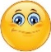  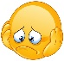  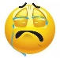 | Date: ___________________________________________________
 | Teacher’s signature:  ___________________________ | Parent’s signature:  ___________________________

Look at the pictures and write.

- The _____________ is _________ the desk.

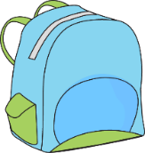
- The _____________ is _________ the schoolbag.

- The _____________ is _________ the chair.

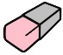
- The _____________ is _________ the pencil sharpener.

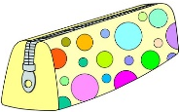

- The _____________ are _________ the pencil case.

ANSWER KEY
- The book is on the desk.
- The ruler is in the schoolbag.
- The pencil is under the chair.
- The rubber is near the pencil sharpener.
- The scissors are near the pencil case.

