Name: ____________________________ Surname: ____________________________ N^{ber}: ____ Grade/Class: _____
Assessment: _____________________________ | Date: ___________________________________________________
 | Teacher’s signature:  ___________________________ | Parent’s signature:  ___________________________

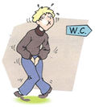
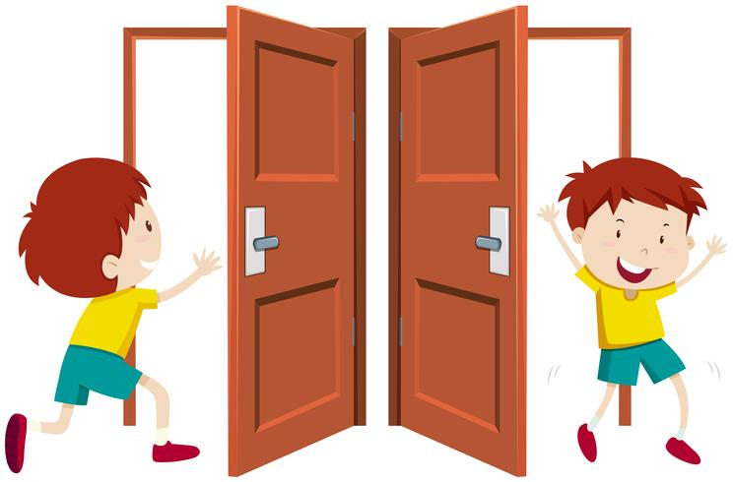
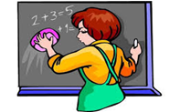
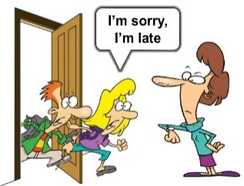
Listen and number.

TRANSCRIPT

1. Can I go to the toilet?
2. May I clean the board?
3. Can I borrow your pencil?
4. Can I put this in the bin?
5. Can you open the window, please?
6. Can I sharpen my pencil?
7. Can I come in? Sorry, I’m late.
8. Can I go out?

ANSWER KEY

1. Can I go to the toilet?
2. May I clean the board?
3. Can I borrow your pencil?
4. Can I put this in the bin?
5. Can you open the window, please?
6. Can I sharpen my pencil?
7. Can I come in? Sorry, I’m late.
8. Can I go out?

