Name: ____________________________ Surname: ____________________________ N^{ber}: ____ Grade/Class: _____
Assessment: _____________________________  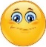  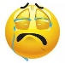 | Date: ___________________________________________________
 | Teacher’s signature:  ___________________________ | Parent’s signature:  ___________________________

Listen and draw lines.
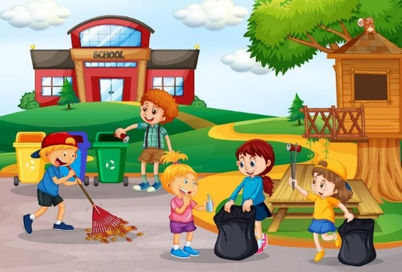

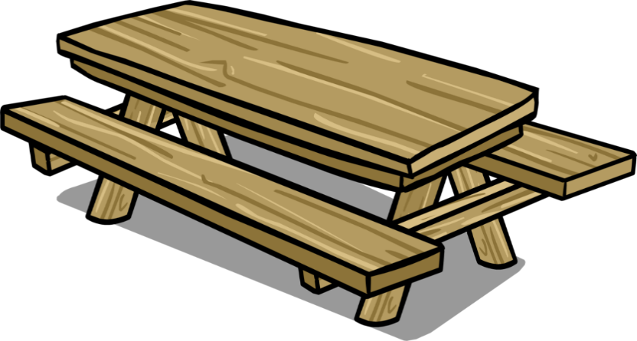

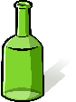
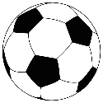
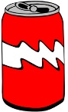

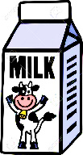
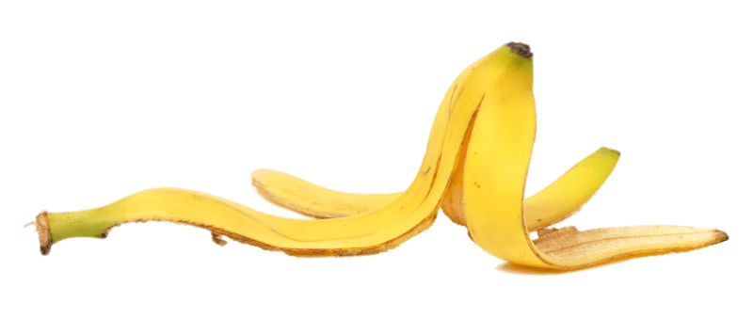
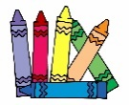

TRANSCRIPT

- Put the plastic bottle in the yellow bin.
- Put the banana peel in the black plastic bag.
- The glass bottle is on the table.
- Put the newspapers in the blue bin.
- The carton of milk is under the table
- The can is near the ball.

ANSWER KEY

- plastic bottle in the yellow bin
- banana peel in the black plastic bag
- glass bottle on the table
- newspapers in the blue bin
- carton of milk under the table
- can near the ball.

