Name: ____________________________ Surname: ____________________________ N^{ber}: ____ Grade/Class: _____
Assessment: _____________________________ | Date: ___________________________________________________
 | Teacher’s signature:  ___________________________ | Parent’s signature:  ___________________________

1) Listen and tick.

- Which is Adam? a) b) c)

- Which is Sarah? a) b) c)

- Which is Kate? a) b) c)

- Which is Jenny? a) b) c)

- Which is Peter? a) b) c)

2) Listen and number.
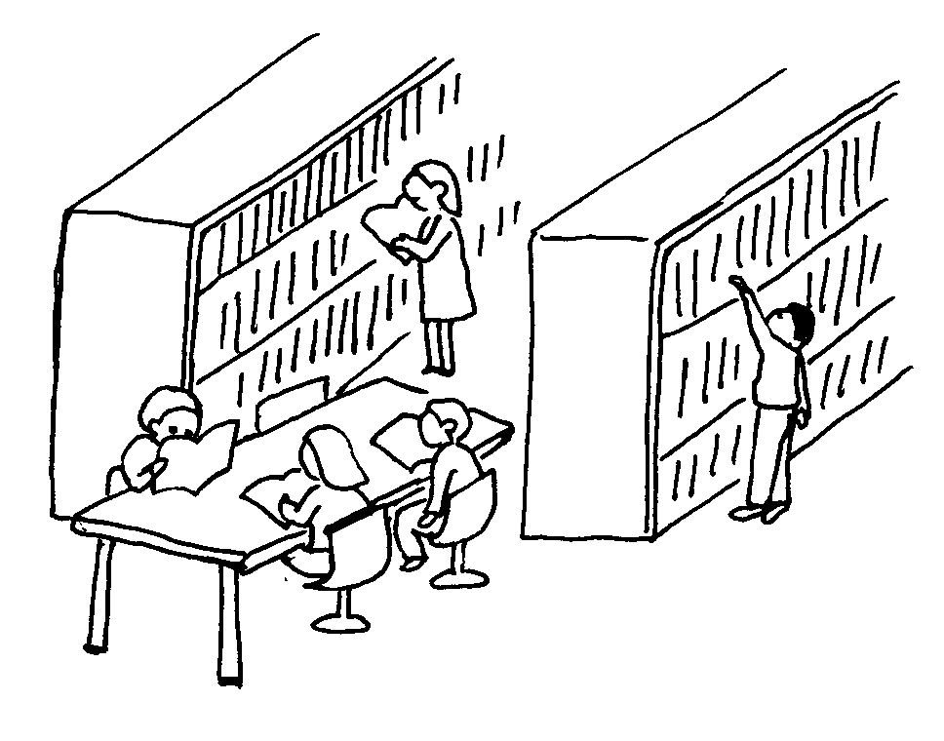

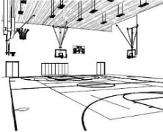
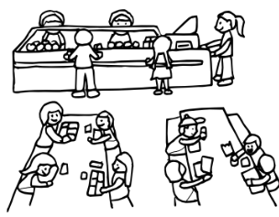

TRANSCRIPT

EXERCISE 1

1.
Which is Adam?
Girl: Is Adam playing football?
Boy: No, he doesn’t like football.
Girl: Is he writing?
Boy: Yes, he’s writing a letter to his uncle.
2.
Which is Sarah?
Girl: I can’t ﬁnd Sarah!
Boy: She’s at the playground!
Girl: Is she? Where? Is she playing on the slide?
Boy: Yes she is. She loves playing on the slide.
3.
Which is Kate?
Girl: Is Kate reading a book?
Boy: No, she’s running.
Girl: Yes. She likes running a lot.
4.
Which is Jenny?
Girl: Is Jenny singing with her friends?
Boy: No, she’s dancing in the gym.
5.
Which is Peter?
Girl: Is Peter drawing?
Boy: No, he doesn’t like drawing.
Girl: Is he listening to music?
Boy: Yes, he’s listening to music in the library.

EXERCISE 2

1. Gym / 2. Playground / 3. Canteen / 4. Computer room / 5. Library / 6. Classroom / 7. Music room / 8. Art room

ANSWER KEY

EXERCISE 1
- b
- a
- b
- c
- c

EXERCISE 2
1. Gym / 2. Playground / 3. Canteen / 4. Computer room / 5. Library / 6. Classroom / 7. Music room / 8. Art room

