Name: ____________________________ Surname: ____________________________ N^{ber}: ____ Grade/Class: _____
Assessment: _____________________________ | Date: ___________________________________________________
 | Teacher’s signature:  ___________________________ | Parent’s signature:  ___________________________

Listen and tick.
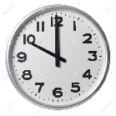
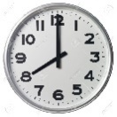
- What time is school?
a) b) c)

- How many computers are there?
12
6
0
a) b) c)

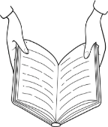
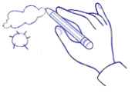
- What is Kate doing?
a) b) c)

- How many students are there?
11
24
13
a) b) c)

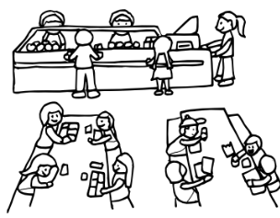
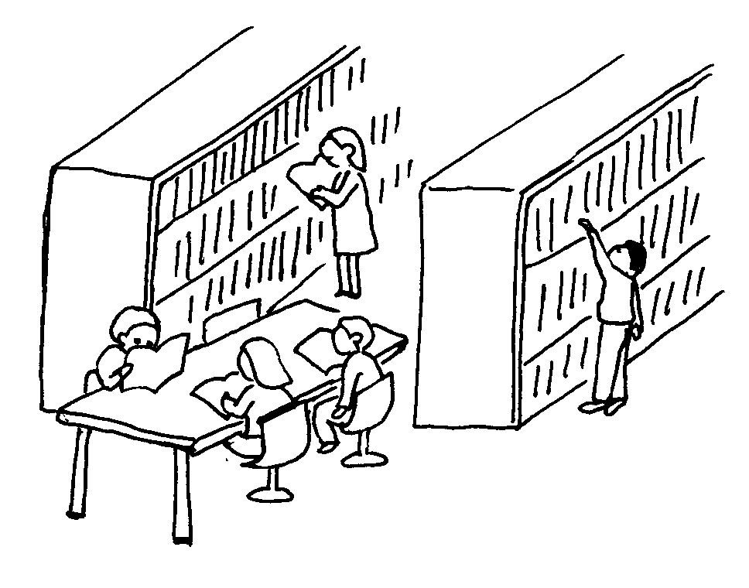
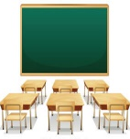
- Where’s the teacher?
a) b) c)

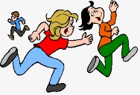
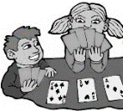
- What are the children doing?
a) b) c)

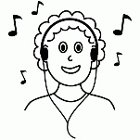
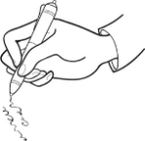
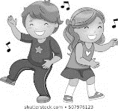
- What is the girl’s favourite activity?
a) b) c)

8) Peter picks up…
a) b) c)

TRANSCRIPT

1.
Girl: Excuse-me, I’m a new student. Can you tell me what time is school?
Teacher: at nine and the interval is at ten.
Girl: Thank you.
2.
Girl: Is there a computer room in the school?
Boy: No, there isn’t but There are twelve computers in the library.
Girl: Thank you.
3.
Girl: Is Kate drawing?
Boy: No, she doesn’t like drawing.
Girl: She is reading a book in the library. She loves reading.
4.
Girl: How many students are there in the class?
Boy: well, let me think, there are 13 boys and 11 girls.
Girl: 24 students, it’s a big class.
5.
Girl: Where is the teacher?
Boy: In the classroom I think.
Girl: No he isn’t.
Boy: Oh, it’s twelve o’clock, he’s in the canteen.
6.
Boy: What are the children doing? Are they playing cards?
Girl: No. They are playing computer games in the library.
7.
Boy: Do you like dancing?
Girl: Yes, I do but my favourite classroom activity is writing.
8.
Teacher: Peter! Please, pick up the plastic bottle and put it in the yellow bin.
Girl: Where’s the plastic bottle?
Teacher: Over there, near the slide.
Girl: Ah, OK.

ANSWER KEY

- b
- c
- a
- b
- c
- a
- c
- b

